**A HYBRID DEEP LEARNING MODEL TO PREDICT HIGH-RISK STUDENTS IN VIRTUAL LEARNING ENVIRONMENTS**

**Abstract**  
In the evolving domain of virtual learning environments, identifying high-risk students early is essential to ensure timely academic intervention and support. Traditional manual approaches—such as reviewing attendance records, performance logs, and instructor observations—are time-consuming, subjective, and often fail to scale with large student populations. To address these limitations, this research proposes a **Hybrid Deep Learning Model** that integrates Convolutional Neural Networks (CNN), Gated Recurrent Units (GRU), and ResNet1D architectures to predict at-risk students based on academic and engagement-related data. The system employs Butterfly Optimization Algorithm (BOA) for effective feature selection, followed by model training using four variants: ResNet1D, Enhanced CNN, CNN-GRU Hybrid, and CNN with XGBoost classifier. Each model's performance is evaluated using precision, recall, F1-score, and accuracy, enabling educators to make data-driven decisions. The platform, built using Django, facilitates secure user management, data upload, preprocessing, visualization, and real-time predictions. Extensive experimentation confirms that the hybrid CNN-GRU model demonstrates superior generalization and accuracy. This solution not only automates risk prediction but also enhances scalability and reliability in educational data analysis.

**CHAPTER 1**

**INTRODUCTION**

**1.1 Overview**

The rapid adoption of virtual learning environments (VLEs) has transformed the education system by providing flexibility, scalability, and accessibility. However, with the growing use of digital platforms, it has become increasingly challenging to track and evaluate student performance in real time. In traditional classrooms, teachers could identify at-risk students based on participation, facial expressions, and one-on-one interactions. In contrast, VLEs remove these in-person cues, making it difficult to detect students who are likely to fail or drop out. This issue has drawn attention to the need for data-driven, intelligent systems that can automatically detect students who may be academically at risk.

To address this concern, this project proposes a **hybrid deep learning model** that leverages both CNN and GRU architectures, along with ResNet1D and CNN-XGBoost combinations, to predict high-risk students using educational and behavioral data. The system incorporates a Butterfly Optimization Algorithm (BOA) for feature selection to ensure high-performance learning and accuracy. The platform is developed using Django as a web interface, making it accessible for academic institutions to upload student datasets, preprocess data, train models, and visualize results in a user-friendly format.

The proposed system automates the prediction process, enabling timely interventions by educators, counselors, and institutions. By converting raw educational records into meaningful insights, it ensures that students who need attention are not overlooked. The integration of machine learning, deep learning, and optimization techniques creates a robust predictive framework capable of handling diverse and complex datasets. Overall, this project offers a scalable and intelligent solution to support academic success and reduce dropout rates in virtual learning setups, which are becoming the norm in the post-pandemic world.

**1.2 Problem Statement**

Virtual learning environments (VLEs) offer flexibility and access to education at a global scale, but they also pose significant challenges in monitoring student engagement, performance, and risk. One of the critical problems in these platforms is the **inability to accurately identify high-risk students**, particularly those who are disengaged, underperforming, or likely to drop out. Unlike traditional classroom settings, VLEs lack physical cues and in-person interactions, making it difficult for instructors to monitor student behavior, provide timely feedback, or offer personalized support.

Current methods of identifying at-risk students are mostly **manual or rule-based**, relying on instructors to review logs, assess assignments, or analyze exam scores. These approaches are not only time-consuming but also subjective and inconsistent, often failing to detect early signs of academic struggle. Furthermore, in institutions with large student populations, such manual evaluation becomes impractical and inefficient. The lack of real-time, intelligent systems leads to missed opportunities for intervention and support, ultimately resulting in higher dropout rates and poor academic outcomes.

This project aims to **automate the identification of high-risk students** using a hybrid deep learning model that integrates multiple neural network architectures with optimization techniques. By analyzing patterns in historical student data, engagement records, and academic performance, the model predicts students who are likely to underperform. The challenge lies in handling high-dimensional data, selecting relevant features, training efficient models, and delivering accurate predictions through a user-friendly platform. The system not only overcomes the limitations of manual methods but also introduces scalability, reliability, and timeliness in predicting academic risk.

The research, therefore, focuses on developing a hybrid intelligent model with strong generalization ability, minimal human intervention, and high predictive accuracy to solve the persistent problem of early student risk detection in virtual learning environments.

**1.3 Research Motivation**

The increasing shift toward online education has highlighted a critical gap in educational technology: the lack of real-time systems to identify and support high-risk students. Traditional education systems allow teachers to monitor students through direct interaction, immediate feedback, and classroom participation. However, in virtual learning environments (VLEs), this level of observation is not feasible. As a result, students struggling academically or emotionally may go unnoticed until it is too late. The motivation for this research stems from a **deep need to address this shortcoming** using intelligent, automated solutions.

Several educational institutions have reported a rise in dropout rates and performance gaps due to the absence of real-time monitoring and intervention mechanisms. This research is inspired by the potential of deep learning models to **analyze large volumes of educational data**, discover hidden patterns, and make timely predictions about student risk. Leveraging this potential can drastically improve academic outcomes, reduce failure rates, and enable early counseling and remediation.

Moreover, most existing academic risk detection systems use basic statistical or rule-based models that lack adaptability and scalability. They often fail when exposed to diverse datasets or unseen data, making them unreliable in dynamic educational contexts. A hybrid deep learning approach that combines CNN, GRU, and ResNet architectures with an optimization algorithm like Butterfly Optimization can provide **more accurate, interpretable, and generalizable results**.

The research also aims to bridge the gap between model development and practical implementation. By integrating the model into a Django-based web application, we ensure that educators and administrators can easily use the system without technical expertise. The motivation, therefore, lies not only in improving prediction accuracy but also in **enhancing usability and impact**—making advanced AI tools accessible for real-world educational challenges.

**1.4 Applications**

The proposed hybrid deep learning model offers numerous practical applications across educational institutions, e-learning platforms, and policy-making bodies focused on academic success and retention. One of the primary applications is **early intervention**. By predicting which students are likely to fail or drop out based on their performance and engagement data, educators can intervene proactively. Timely intervention allows for tailored support, such as additional tutoring, counseling, or adjustments in coursework, thereby improving student outcomes.

Another significant application is in **automated academic monitoring systems** for universities, colleges, and online learning platforms. The integration of the model into a web-based platform enables automated tracking of student risk profiles, eliminating the need for manual analysis. Academic counselors and administrators can use the dashboard to monitor trends, compare performance across departments, and allocate resources more effectively.

The system also serves as a **decision-support tool** for curriculum designers and education policymakers. By analyzing trends in student data, the model can help identify curriculum areas that require improvement or modules that are consistently challenging for students. This can inform curriculum restructuring, the introduction of support modules, or redesigning course content to address common student difficulties.

Beyond the classroom, the model can be integrated into **massive open online course (MOOC)** platforms, enabling scalable, AI-driven student analytics. EdTech companies can deploy such models to offer performance dashboards, progress alerts, and personalized learning suggestions to users. Furthermore, institutions involved in accreditation or quality assurance can utilize the system as part of their continuous evaluation processes.

In summary, the system has far-reaching applications in improving **academic retention, quality assurance, personalized education, and institutional efficiency**, making it an essential tool for modern, data-driven educational ecosystems.

**CHAPTER 2**

**LITERATURE SURVEY**

**[1] Ahn et al. (2021)** conducted a study using machine learning techniques to identify youths at high risk of aging out of foster care. They demonstrated how predictive analytics could be leveraged to support early intervention. Their work emphasizes the importance of accurate identification in social and educational systems.

**[2] Dembo and Walters (2003)** explored innovative approaches to addressing the needs of high-risk youth. They stressed the role of early detection and targeted intervention using data-driven tools, laying foundational concepts for risk classification and behavior tracking.

**[3] Severson et al. (2007)** proposed early behavioral screening strategies to detect at-risk students. Their research discussed proactive systems and emerging innovations in educational psychology, highlighting the need for early warning mechanisms in learning environments.

**[4] Yağcı (2022)** applied machine learning algorithms to predict academic performance using educational data mining techniques. The study showed strong accuracy results with decision tree and support vector models and validated the importance of behavior-based indicators.

**[5] Olaleye and Vincent (2020)** developed a model that classifies students’ performance levels and identifies associated risk indicators. Their work utilized supervised learning to achieve predictive goals and supported educators in performance forecasting and intervention.

**[6] Marwaha and Singla (2020)** analyzed multiple machine learning methods to predict at-risk students based on behavioral and academic data. The study revealed that ensemble and hybrid techniques produced better results than individual models.

**[7] Embarak (2020)** applied ML algorithms at the time of admission to predict future academic risk. The findings confirmed that early prediction during the onboarding phase can help institutions make informed placement and mentoring decisions.

**[8] Xiao et al. (2022)** provided a comprehensive survey of educational data mining methods used for predicting student performance. They reviewed models like decision trees, neural networks, and clustering techniques, concluding that hybrid approaches often yield superior accuracy.

**[9] Bujang et al. (2021)** proposed a predictive model using supervised machine learning for academic grade prediction. Their system incorporated data preprocessing and model tuning to achieve high performance and improve institutional academic planning.

**[10] Ismail et al. (2021)** conducted a comparative analysis of various machine learning models. Their findings emphasized the importance of algorithm selection and data preparation in achieving optimal prediction accuracy for student performance.

**[11] Gaftandzhieva et al. (2022)** examined online student activity logs to predict final grades. The study utilized interaction features like page views and submission times, highlighting how student engagement metrics are crucial predictors in virtual learning platforms.

**[12] Ayienda et al. (2021)** developed a hybrid machine learning model for academic performance prediction. By combining different classifiers, the model achieved improved accuracy and robustness, showcasing the value of ensemble learning in educational applications.

**[13] Kalyani et al. (2020)** evaluated neural network models for assessing student performance. Their study demonstrated that multilayer perceptrons and backpropagation algorithms can effectively model complex student behavior patterns.

**[14] Naicker et al. (2020)** used linear support vector machines to predict student outcomes in school-based education systems. Their approach emphasized simplicity, interpretability, and effective feature selection for early identification of struggling learners.

**[15] Wang et al. (2020)** incorporated short-term campus behavior data into student performance models. Using time-series features, they demonstrated how recent behavioral patterns significantly influence academic predictions.

**[16] Neha et al. (2021)** designed a deep neural network to identify important predictive variables affecting academic performance. Their model showed that deep learning can automatically extract high-value features from raw educational data.

**[17] Begum and Padmannavar (2022)** proposed an ensemble model optimized by genetic algorithms for multiclass student performance classification. The optimization improved both precision and recall, offering a reliable framework for academic risk analysis.

**CHAPTER 3 EXISTING SYSTEM**

**3.1 Existing System**

In traditional educational environments, student performance evaluation and risk identification were largely manual, relying on teacher observations, test scores, and attendance records. Educators would assess students through periodic exams and use predefined grading scales to measure academic success. These systems operated under the assumption that academic performance alone was sufficient to determine student success or failure. However, this approach often overlooked behavioral, psychological, and socio-economic factors that influence learning outcomes.

Rule-based systems emerged as an early attempt to automate risk detection. These systems depended on a fixed set of if-then rules derived from expert knowledge or institutional policies. For example, if a student’s attendance dropped below 75%, or if their test scores remained consistently below a threshold, they were flagged as “at risk.” Such systems used structured inputs and followed logical decision paths to generate alerts or classify students into performance categories.

While rule-based systems introduced some level of automation, they lacked adaptability and could not learn from new data. Their rigidity often resulted in false positives or missed outliers, as they could not accommodate nuances such as emotional well-being, learning disabilities, or digital engagement patterns in online platforms. Moreover, they failed to model the complex, non-linear relationships between various academic and behavioral factors.

With the rise of digital learning environments and the increasing availability of data from learning management systems (LMS), these traditional and rule-based approaches became insufficient. The need for dynamic, data-driven solutions that could interpret large volumes of unstructured and heterogeneous student data in real time has led to the growing interest in machine learning and deep learning models. These modern approaches offer the potential to build more accurate, responsive, and individualized student support systems, far surpassing the capabilities of existing systems.

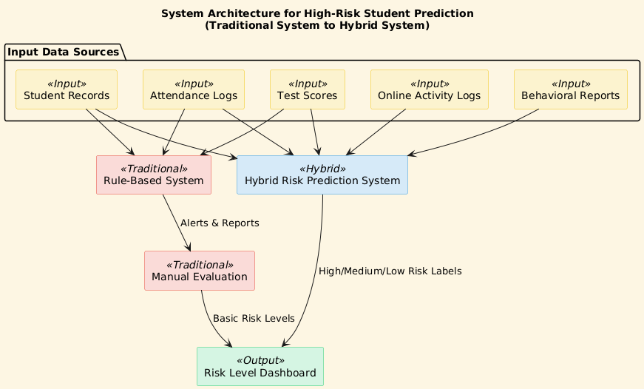

**3.2 Limitations**

Despite their historical significance, traditional and rule-based systems present several limitations when applied to the identification of high-risk students in modern educational settings. First, these systems rely on static thresholds and predefined conditions, which do not adapt to the diverse and evolving nature of student behavior. They often fail to capture non-linear patterns, subtle indicators, or interactions between multiple variables that may signal academic risk.

Moreover, rule-based systems are highly domain-dependent and require constant updates to remain relevant in dynamic learning environments. Their inability to handle large-scale, real-time data from online platforms restricts their effectiveness in virtual learning contexts. Additionally, these systems often exclude vital factors such as socio-emotional data, mental health indicators, and online engagement metrics, leading to incomplete or inaccurate risk assessments.

Another major drawback is the high rate of false classifications. Many students may be wrongly flagged as at risk or overlooked altogether, resulting in misallocation of educational resources. Finally, traditional systems provide limited insights for proactive intervention, offering little guidance beyond basic classification. These shortcomings highlight the necessity for intelligent, adaptive systems that can analyze complex datasets and provide personalized insights—capabilities that traditional and rule-based systems inherently lack.

**CHAPTER 4**

**PROPOSED SYSTEM**

**4.1 Proposed System**

The proposed system is designed to accurately predict high-risk students in virtual learning environments by leveraging a hybrid deep learning model. Unlike traditional rule-based systems, which rely heavily on static thresholds and predefined logic, the proposed model integrates multiple neural network architectures and optimization techniques to identify students who are likely to underperform or drop out. The system begins with dataset upload functionality, allowing administrators or staff to input new academic and behavioral data. Following this, a robust preprocessing pipeline cleans, encodes, and scales the input data, ensuring consistency and reducing noise.

A key innovation in the proposed system is the use of **Butterfly Optimization Algorithm (BOA)** for hyperparameter tuning. BOA is inspired by the food foraging behavior of butterflies and excels in balancing exploration and exploitation. This optimization enhances the performance of subsequent learning models. The backbone of the system includes several deep learning techniques: **ResNet1D**, which handles residual connections effectively in time-series educational data; **Enhanced CNN**, which captures hierarchical data patterns; **Hybrid CNN-GRU**, combining convolutional feature extraction with GRU's temporal memory for behavioral sequences; and **CNN with XGBoost**, where extracted features are passed to a powerful gradient boosting classifier.

These individual models are evaluated using metrics such as accuracy, precision, recall, and F1-score. The best-performing model is used for the final prediction on test data. By employing multiple architectures and selecting the optimal one, the system ensures robustness and adaptability across different datasets. The final predictions are visualized in a user-friendly dashboard, empowering educational institutions to take proactive interventions. Overall, this system shifts from manual assessments to a data-driven predictive framework that can handle complex, large-scale student data efficiently, supporting personalized learning and dropout prevention strategies in virtual learning ecosystems.

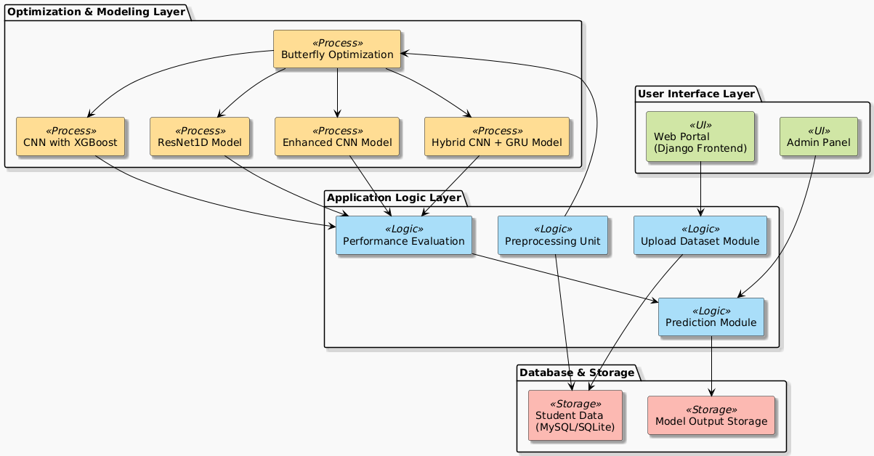

**4.2 Module Split-Up**

1. **Upload Dataset**: This module allows administrators to upload student-related datasets in CSV format. The uploaded data may include demographic information, academic records, attendance, online participation, and behavioral logs. A validation check ensures the format and schema are consistent before processing.
2. **Data Preprocessing**: Raw data often contains missing values, duplicates, and inconsistent formats. This module applies techniques such as null handling, categorical encoding (Label or One-Hot), normalization (e.g., MinMaxScaler), and feature selection. This step ensures uniform and clean input for the model pipeline.
3. **Butterfly Optimization**: The Butterfly Optimization Algorithm (BOA) is used to fine-tune hyperparameters such as learning rate, batch size, number of filters, dropout rates, etc. It mimics butterflies' sensory perception during foraging, balancing exploration and exploitation to reach global optima in a complex parameter space.
4. **ResNet1D Algorithm**: This module implements a one-dimensional Residual Neural Network to process sequential or tabular student data. It reduces the vanishing gradient problem through identity shortcut connections, enabling deeper networks to train efficiently.
5. **Enhanced CNN**: This module employs a deeper CNN architecture with additional convolutional and pooling layers. It captures both local and global patterns in educational datasets, like spikes in student activity or irregular attendance.
6. **Hybrid CNN (CNN + GRU)**: This hybrid model extracts spatial features using CNN and models temporal dependencies with GRU (Gated Recurrent Unit). It is especially useful for sequential data such as time-stamped activities or clickstream logs.
7. **CNN with XGBoost**: After CNN-based feature extraction, this module uses XGBoost (Extreme Gradient Boosting) to perform classification. XGBoost handles imbalanced data effectively and improves generalization.
8. **Performance Evaluation**: This module calculates evaluation metrics such as accuracy, precision, recall, and F1-score on validation data. Confusion matrices and ROC curves are also generated for a detailed model assessment.
9. **Prediction on Test Data**: Once trained and validated, the model is deployed to predict risk labels on unseen test data. The predictions are displayed on the dashboard and can be downloaded for reporting purposes.

**4.3 Butterfly Optimization**

The Butterfly Optimization Algorithm (BOA) is a nature-inspired metaheuristic algorithm based on the food-searching behavior of butterflies using scent. In the proposed system, BOA is applied to optimize hyperparameters in various deep learning models such as ResNet1D, CNN, and Hybrid CNN-GRU. The optimization process is critical to improving the generalization capability and convergence of deep networks.

BOA simulates two phases: global and local search. In the global phase, butterflies are assumed to move towards the best-scented butterfly in the population, ensuring exploration of the global search space. In the local phase, butterflies randomly interact with neighboring butterflies to exploit the best solutions found so far. These transitions between global and local search are controlled by a switching probability.

The algorithm starts by initializing a random population of potential hyperparameter sets. Each butterfly’s position represents a specific configuration of hyperparameters, such as learning rate, dropout rate, number of convolutional filters, and number of neurons in dense layers. A fitness function, based on model accuracy or loss, evaluates each configuration. Through iterations, the butterflies converge towards the optimal set of hyperparameters that yield the highest performance.

BOA is particularly effective in the proposed system due to its simplicity, fewer parameters to tune compared to other metaheuristics, and its ability to escape local optima. Its integration into the pipeline automates the tuning process, saving development time and avoiding the pitfalls of manual grid or random search. As a result, BOA enhances the learning efficiency of the predictive models used in this system, leading to more accurate identification of at-risk students in online learning environments.

**4.4 ResNet1D**

ResNet1D (1-Dimensional Residual Network) is an adaptation of the classic ResNet architecture tailored for one-dimensional sequential or tabular data, such as student performance logs, clickstream data, or time-series attendance records. In this system, ResNet1D is implemented to capture hierarchical representations of student-related patterns without encountering issues like vanishing gradients, which often hinder deep network training.

The ResNet1D model consists of multiple convolutional layers followed by batch normalization, ReLU activations, and shortcut (residual) connections. These shortcut connections bypass one or more layers, allowing the network to retain and propagate important features. This structure facilitates the learning of both shallow and deep features simultaneously. The model accepts one-dimensional input vectors, processes them through stacked residual blocks, and produces a flattened vector passed to fully connected layers for classification.

One of the major strengths of ResNet1D lies in its ability to preserve context in long sequences and emphasize relevant patterns like gradual decline in attendance or frequent missing assignments. These trends might not be immediately evident to traditional models but can be effectively learned by a residual network.

ResNet1D also benefits from reduced overfitting due to its parameter-sharing architecture and efficient feature reuse. It is particularly suitable for educational datasets where input features may represent a time dimension or ordered academic progression. The model's robustness and training efficiency make it an ideal component in the hybrid ensemble system. Its predictions serve as a reliable baseline and are often used in combination with other models like CNN-GRU or CNN-XGBoost to improve classification accuracy and stability.

**4.5 Enhanced CNN**

The Enhanced CNN (Convolutional Neural Network) module is a deepened and fine-tuned version of the standard CNN architecture designed to extract spatial and temporal patterns from educational datasets. While traditional CNNs are primarily used in image processing, their architecture can be adapted to structured data where spatial patterns exist — for example, across different time intervals of student engagement or among correlated performance metrics.

The Enhanced CNN in this system includes multiple convolutional layers with increased filter depth, batch normalization, and dropout layers to prevent overfitting. Pooling layers, such as max pooling, help reduce dimensionality and retain dominant features. This design enables the model to detect subtle changes in student behavior patterns and academic trends across various input features.

For example, in student activity logs, the Enhanced CNN can detect patterns of inactivity, short bursts of engagement before exams, or steady performance decline — all of which are critical indicators of risk. The model converts high-dimensional input into compact feature vectors that encapsulate meaningful insights, which are then passed through dense layers for classification.

Compared to basic CNN models, this Enhanced version is more robust, capable of handling larger datasets, and better suited for educational prediction tasks. The architecture is also modular, allowing easy integration with optimization techniques like BOA and ensemble methods. The performance of the Enhanced CNN is evaluated using accuracy, precision, recall, and confusion matrices, ensuring a well-rounded assessment before deployment.

Its contribution to the overall ensemble ensures diversity in decision-making, improving the system’s capability to classify high-risk students in varied academic and behavioral contexts.

**4.6 Hybrid CNN (CNN + GRU)**

The Hybrid CNN-GRU model combines the strengths of Convolutional Neural Networks (CNN) and Gated Recurrent Units (GRU) to effectively model spatial and temporal aspects of student data. CNN is responsible for extracting local features and patterns such as regular attendance or high activity in forums, while GRU captures sequential dependencies, such as consistent academic decline or gradual disengagement over time.

The CNN layers in this hybrid architecture perform feature extraction using multiple convolutional filters, followed by pooling and flattening. The output from the CNN is then fed into the GRU layer, which processes this sequence to retain long-term dependencies using gating mechanisms. GRU is preferred over traditional RNNs due to its efficiency and fewer parameters, making it suitable for moderately sized educational datasets.

This combination proves particularly effective in virtual learning environments, where students’ interactions occur over a timeline — such as logins, assignment submissions, quiz participation, and discussion activity. GRU can identify periodic behaviors or abrupt drop-offs, which might signal students at risk.

The hybrid model provides a comprehensive view of each student by considering both static features (e.g., grade history) and temporal behavior (e.g., login frequency). It outperforms single models in both accuracy and generalization. After training, the model outputs risk scores categorized into high, medium, or low-risk levels. These predictions are valuable for instructors and educational institutions to initiate early intervention strategies.

The CNN-GRU model is an integral part of the ensemble system, offering nuanced risk predictions by learning from complex educational timelines, and enhancing the reliability of the proposed high-risk student identification framework.

**4.7 CNN with XGBoost**

The CNN with XGBoost model is a hybrid approach where the feature extraction capability of Convolutional Neural Networks (CNN) is combined with the powerful classification ability of the XGBoost algorithm. This fusion leverages the strengths of both deep learning and ensemble tree-based methods, making it highly effective in predicting at-risk students in educational settings.

Initially, the CNN component processes structured educational data through multiple convolutional and pooling layers, transforming raw inputs into high-level feature vectors. These features encapsulate patterns such as activity frequency, assignment submission consistency, and interaction levels in virtual learning platforms. Unlike traditional models, CNN automatically learns to extract relevant features without manual engineering.

Once features are extracted, they are flattened and passed to the XGBoost classifier. XGBoost (Extreme Gradient Boosting) is known for its high accuracy, speed, and handling of missing or imbalanced data. It constructs a series of decision trees iteratively and combines their outputs to minimize error. In this system, XGBoost uses CNN-derived features to classify students into risk categories.

This hybrid setup is advantageous in educational data mining because CNN handles spatial data correlations while XGBoost delivers robust and interpretable classification. Moreover, XGBoost’s feature importance scores help in understanding which CNN-derived features contribute most to the final prediction, adding a layer of explainability.

CNN with XGBoost is particularly beneficial when datasets are tabular but contain complex dependencies. It balances deep learning’s feature learning with XGBoost’s generalization power, resulting in a well-rounded, high-performance model for student risk prediction. This model is used as one of the candidates in the proposed system’s ensemble evaluation, contributing to the overall prediction confidence and decision diversity.

**4.8 Applications**

The proposed hybrid deep learning system for predicting high-risk students in virtual learning environments has a wide range of impactful applications across the education sector. One of the primary applications is **early intervention and support**. By identifying students who are likely to struggle or drop out, educational institutions can implement timely academic counseling, provide personalized learning resources, and engage in proactive mentoring, thereby improving student retention and success rates.

Another critical application lies in **academic performance monitoring**. With continuous predictions based on updated student data, institutions can monitor academic trends in real time. This allows faculty and administrators to dynamically adjust course content, teaching methodologies, or assessment structures to better suit the needs of the learners. Moreover, it enables data-driven decisions in curriculum planning and pedagogy refinement.

The system also benefits **e-learning platforms and Learning Management Systems (LMS)**. By integrating predictive models into LMS dashboards, these platforms can offer intelligent insights, such as highlighting at-risk students, recommending targeted content, or automating alerts for academic advisors and parents. This enhances the user experience and fosters a more responsive learning environment.

In addition, the system has significant applications in **policy-making and resource allocation**. Administrators can utilize predictive insights to channel funding and support toward departments or demographics that need the most assistance. This ensures equitable access to resources and helps bridge performance gaps across different student groups.

Beyond formal education, the system can be adapted for **vocational training institutes, online certification platforms, and corporate training environments**, where learner engagement and timely course completion are essential.

Overall, this proposed system transforms traditional, reactive academic monitoring into a **proactive, intelligent, and adaptive educational support mechanism**, fostering academic success and mental well-being in virtual learning spaces.

**CHAPTER 5**

**UML DIAGRAMS**

UML stands for Unified Modeling Language. UML is a standardized general-purpose modeling language in the field of object-oriented software engineering. The standard is managed, and was created by, the Object Management Group. The goal is for UML to become a common language for creating models of object-oriented computer software. In its current form UML is comprised of two major components: a Meta-model and a notation. In the future, some form of method or process may also be added to; or associated with, UML.

The Unified Modeling Language is a standard language for specifying, Visualization, Constructing and documenting the artifacts of software system, as well as for business modeling and other non-software systems. The UML represents a collection of best engineering practices that have proven successful in the modeling of large and complex systems. The UML is a very important part of developing objects-oriented software and the software development process. The UML uses mostly graphical notations to express the design of software projects.

**GOALS:** The Primary goals in the design of the UML are as follows:

* Provide users a ready-to-use, expressive visual modeling Language so that they can develop and exchange meaningful models.
* Provide extendibility and specialization mechanisms to extend the core concepts.
* Be independent of particular programming languages and development process.
* Provide a formal basis for understanding the modeling language.
* Encourage the growth of OO tools market.
* Support higher level development concepts such as collaborations, frameworks, patterns and components.
* Integrate best practices.

**Class diagram**

The class diagram is used to refine the use case diagram and define a detailed design of the system. The class diagram classifies the actors defined in the use case diagram into a set of interrelated classes. The relationship or association between the classes can be either an "is-a" or "has-a" relationship. Each class in the class diagram was capable of providing certain functionalities. These functionalities provided by the class are termed "methods" of the class. Apart from this, each class may have certain "attributes" that uniquely identify the class.

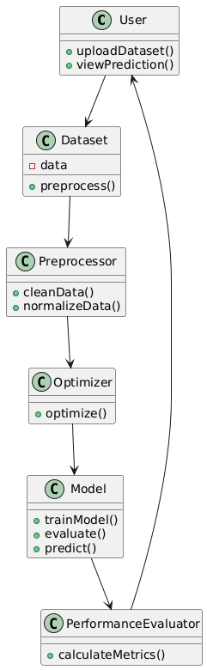

Figure-5.1: Class Diagram

**Sequence Diagram**

A sequence diagram in Unified Modeling Language (UML) is a kind of interaction diagram that shows how processes operate with one another and in what order. It is a construct of a Message Sequence Chart. A sequence diagram shows, as parallel vertical lines (“lifelines”), different processes or objects that live simultaneously, and as horizontal arrows, the messages exchanged between them, in the order in which they occur. This allows the specification of simple runtime scenarios in a graphical manner.

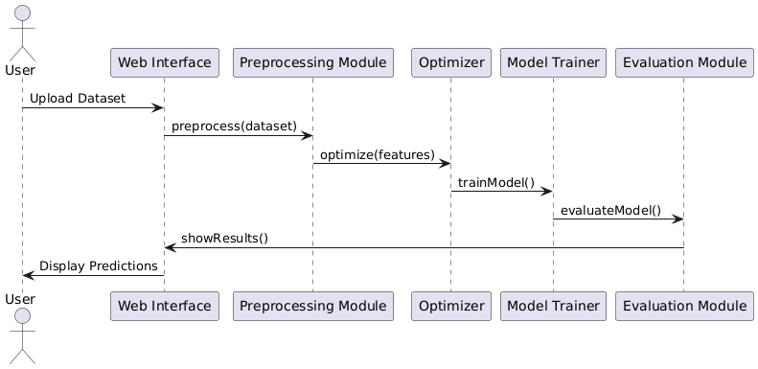

Figure-5.2: Sequence Diagram

**Activity diagram**

Activity diagrams are graphical representations of Workflows of stepwise activities and actions with support for choice, iteration, and concurrency. In the Unified Modeling Language, activity diagrams can be used to describe the business and operational step-by-step workflows of components in a system. An activity diagram shows the overall flow of control.

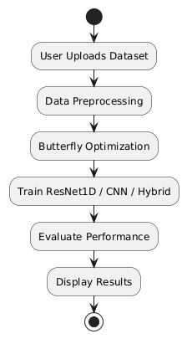

Figure-5.3: Activity Diagram

**Data flow diagram**

A data flow diagram (DFD) is a graphical representation of how data moves within an information system. It is a modeling technique used in system analysis and design to illustrate the flow of data between various processes, data stores, data sources, and data destinations within a system or between systems. Data flow diagrams are often used to depict the structure and behavior of a system, emphasizing the flow of data and the transformations it undergoes as it moves through the system.

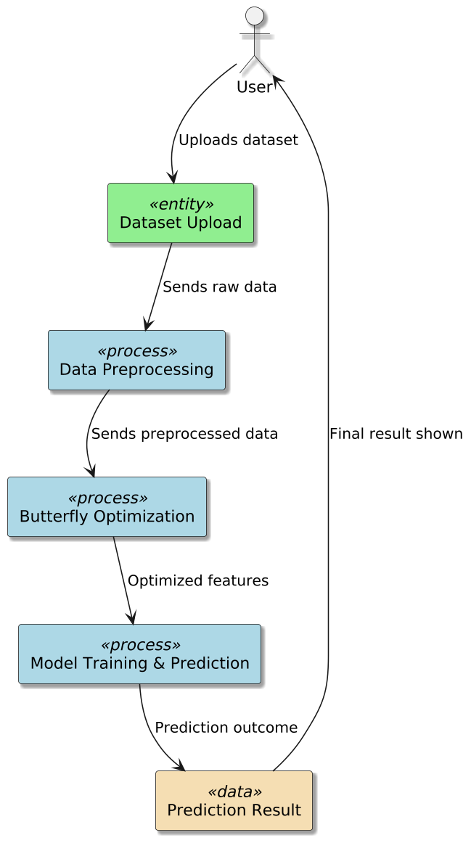

Figure-5.4: Dataflow Diagram

**Component diagram:** Component diagram describes the organization and wiring of the physical components in a system.

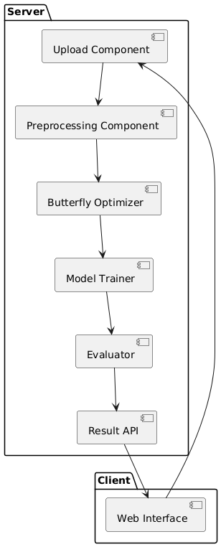

Figure-5.5: Component Diagram

**UseCase diagram:** A use case diagram in the Unified Modeling Language (UML) is a type of behavioral diagram defined by and created from a Use-case analysis. Its purpose is to present a graphical overview of the functionality provided by a system in terms of actors, their goals (represented as use cases), and any dependencies between those use cases. The main purpose of a use case diagram is to show what system functions are performed for which actor. Roles of the actors in the system can be depicted.

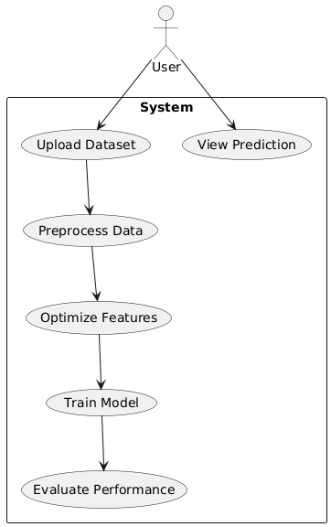

**Deployement Diagram:**

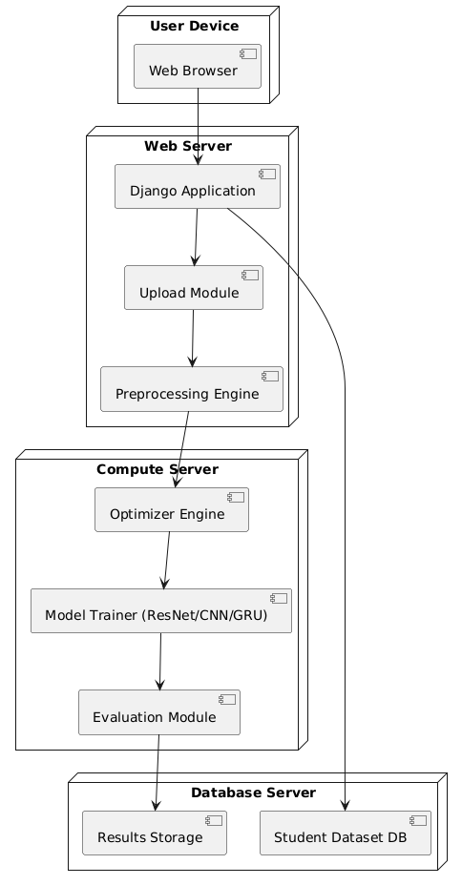

# **SYSTEM REQUIREMENTS**

**➢ H/W System Configuration:-**

**➢ Processor - Pentium –IV**

**➢ RAM - 4 GB (min)**

**➢ Hard Disk - 20 GB**

**➢ Key Board - Standard Windows Keyboard**

**➢ Mouse - Two or Three Button Mouse**

**➢ Monitor - SVGA**

**SOFTWARE REQUIREMENTS:**

1. **Operating system : Windows 7 Ultimate.**
2. **Coding Language : Python.**
3. **Front-End : Python(Tkinter).**

# **SYSTEM STUDY**

**FEASIBILITY STUDY**

The feasibility of the project is analyzed in this phase and business proposal is put forth with a very general plan for the project and some cost estimates. During system analysis the feasibility study of the proposed system is to be carried out. This is to ensure that the proposed system is not a burden to the company. For feasibility analysis, some understanding of the major requirements for the system is essential.

Three key considerations involved in the feasibility analysis are

* ECONOMICAL FEASIBILITY
* TECHNICAL FEASIBILITY
* SOCIAL FEASIBILITY

**ECONOMICAL FEASIBILITY**

This study is carried out to check the economic impact that the system will have on the organization. The amount of fund that the company can pour into the research and development of the system is limited. The expenditures must be justified. Thus the developed system as well within the budget and this was achieved because most of the technologies used are freely available. Only the customized products had to be purchased.

**TECHNICAL FEASIBILITY**

This study is carried out to check the technical feasibility, that is, the technical requirements of the system. Any system developed must not have a high demand on the available technical resources. This will lead to high demands on the available technical resources. This will lead to high demands being placed on the client. The developed system must have a modest requirement, as only minimal or null changes are required for implementing this system.

**SOCIAL FEASIBILITY**

The aspect of study is to check the level of acceptance of the system by the user. This includes the process of training the user to use the system efficiently. The user must not feel threatened by the system, instead must accept it as a necessity. The level of acceptance by the users solely depends on the methods that are employed to educate the user about the system and to make him familiar with it. His level of confidence must be raised so that he is also able to make some constructive criticism, which is welcomed, as he is the final user of the system.

# **SOFTWARE ENVIRONMENT**

**What is Python :-**

Below are some facts about Python.

Python is currently the most widely used multi-purpose, high-level programming language.

Python allows programming in Object-Oriented and Procedural paradigms. Python programs generally are smaller than other programming languages like Java.

Programmers have to type relatively less and indentation requirement of the language, makes them readable all the time.

Python language is being used by almost all tech-giant companies like – Google, Amazon, Facebook, Instagram, Dropbox, Uber… etc.

The biggest strength of Python is huge collection of standard library which can be used for the following –

* + [Machine Learning](https://www.geeksforgeeks.org/machine-learning/)
  + GUI Applications (like Kivy, Tkinter, PyQt etc. )
  + Web frameworks like Django (used by YouTube, Instagram, Dropbox)
  + Image processing (like Opencv, Pillow)
  + Web scraping (like Scrapy, BeautifulSoup, Selenium)
  + Test frameworks
  + Multimedia

**Advantages of Python :-**

Let’s see how Python dominates over other languages.

**1. Extensive Libraries**

Python downloads with an extensive library and it *contain code for various purposes like regular expressions, documentation-generation, unit-testing, web browsers, threading, databases, CGI, email, image manipulation, and more.* So, we don’t have to write the complete code for that manually.

**2. Extensible**

As we have seen earlier, Python can be extended to other languages. You can write some of your code in languages like C++ or C. This comes in handy, especially in projects.

**3. Embeddable**

Complimentary to extensibility, Python is embeddable as well. You can put your Python code in your source code of a different language, like C++. This lets us add scripting capabilities to our code in the other language.

**4. Improved Productivity**

The language’s simplicity and extensive libraries render programmers more productive than languages like Java and C++ do. Also, the fact that you need to write less and get more things done.

**5. IOT Opportunities**

Since Python forms the basis of new platforms like Raspberry Pi, it finds the future bright for the Internet Of Things. This is a way to connect the language with the real world.

**6. Simple and Easy**

When working with Java, you may have to create a class to print ‘Hello World’. But in Python, just a print statement will do. It is also quite easy to learn, understand, and code. This is why when people pick up Python, they have a hard time adjusting to other more verbose languages like Java.

**7. Readable**

Because it is not such a verbose language, reading Python is much like reading English. This is the reason why it is so easy to learn, understand, and code. It also does not need curly braces to define blocks, and indentation is mandatory. This further aids the readability of the code.

**8. Object-Oriented**

This language supports both the procedural and object-oriented programming paradigms. While functions help us with code reusability, classes and objects let us model the real world. A class allows the encapsulation of data and functions into one.

**9. Free and Open-Source**

Like we said earlier, Python is freely available. But not only can you [download Python](https://data-flair.training/blogs/install-python-windows/) for free, but you can also download its source code, make changes to it, and even distribute it. It downloads with an extensive collection of libraries to help you with your tasks.

**10. Portable**

When you code your project in a language like C++, you may need to make some changes to it if you want to run it on another platform. But it isn’t the same with Python. Here, you need to code only once, and you can run it anywhere. This is called Write Once Run Anywhere (WORA). However, you need to be careful enough not to include any system-dependent features**.**

**11. Interpreted**

Lastly, we will say that it is an interpreted language. Since statements are executed one by one, debugging is easier than in compiled languages.

*Any doubts till now in the advantages of Python? Mention in the comment section.*

**Advantages of Python Over Other Languages**

**1. Less Coding**

Almost all of the tasks done in Python requires less coding when the same task is done in other languages. Python also has an awesome standard library support, so you don’t have to search for any third-party libraries to get your job done. This is the reason that many people suggest learning Python to beginners.

**2. Affordable**

Python is free therefore individuals, small companies or big organizations can leverage the free available resources to build applications. Python is popular and widely used so it gives you better community support.

The 2019 Github annual survey showed us that Python has overtaken Java in the most popular programming language category.

**3. Python is for Everyone**

Python code can run on any machine whether it is Linux, Mac or Windows. Programmers need to learn different languages for different jobs but with Python, you can professionally build web apps, perform data analysis and [machine learning](https://data-flair.training/blogs/machine-learning-tutorials-home/), automate things,do web scraping and also build games and powerful visualizations. It is an all-rounder programming language.

**Disadvantages of Python**

So far, we’ve seen why Python is a great choice for your project. But if you choose it, you should be aware of its consequences as well. Let’s now see the downsides of choosing Python over another language.

**1. Speed Limitations**

We have seen that Python code is executed line by line. But since [Python](https://www.python.org/) is interpreted, it often results in slow execution. This, however, isn’t a problem unless speed is a focal point for the project. In other words, unless high speed is a requirement, the benefits offered by Python are enough to distract us from its speed limitations.

**2. Weak in Mobile Computing and Browsers**

While it serves as an excellent server-side language, Python is much rarely seen on the client-side. Besides that, it is rarely ever used to implement smartphone-based applications. One such application is called Carbonnelle.

The reason it is not so famous despite the existence of Brython is that it isn’t that secure.

**3. Design Restrictions**

As you know, Python is dynamically-typed. This means that you don’t need to declare the type of variable while writing the code. It uses duck-typing. But wait, what’s that? Well, it just means that if it looks like a duck, it must be a duck. While this is easy on the programmers during coding, it can raise run-time errors.

**4. Underdeveloped Database Access Layers**

Compared to more widely used technologies like JDBC (Java DataBase Connectivity) and ODBC (Open DataBase Connectivity), Python’s database access layers are a bit underdeveloped. Consequently, it is less often applied in huge enterprises.

**5. Simple**

No, we’re not kidding. Python’s simplicity can indeed be a problem. Take my example. I don’t do Java, I’m more of a Python person. To me, its syntax is so simple that the verbosity of Java code seems unnecessary.

This was all about the Advantages and Disadvantages of Python Programming Language.

**History of Python : -**

What do the alphabet and the programming language Python have in common? Right, both start with ABC. If we are talking about ABC in the Python context, it's clear that the programming language ABC is meant. ABC is a general-purpose programming language and programming environment, which had been developed in the Netherlands, Amsterdam, at the CWI (Centrum Wiskunde &Informatica). The greatest achievement of ABC was to influence the design of Python.Python was conceptualized in the late 1980s. Guido van Rossum worked that time in a project at the CWI, called Amoeba, a distributed operating system. In an interview with Bill Venners1, Guido van Rossum said: "In the early 1980s, I worked as an implementer on a team building a language called ABC at Centrum voor Wiskunde en Informatica (CWI). I don't know how well people know ABC's influence on Python. I try to mention ABC's influence because I'm indebted to everything I learned during that project and to the people who worked on it."Later on in the same Interview, Guido van Rossum continued: "I remembered all my experience and some of my frustration with ABC. I decided to try to design a simple scripting language that possessed some of ABC's better properties, but without its problems. So I started typing. I created a simple virtual machine, a simple parser, and a simple runtime. I made my own version of the various ABC parts that I liked. I created a basic syntax, used indentation for statement grouping instead of curly braces or begin-end blocks, and developed a small number of powerful data types: a hash table (or dictionary, as we call it), a list, strings, and numbers."

**Modules Used in Project**

**TensorFlow**

TensorFlow is a free and open-source software library for dataflow and differentiable programming across a range of tasks. It is a symbolic math library and is also used for machine learning applications such as neural networks. It is used for both research and production at Google.‍

TensorFlow was developed by the Google Brain team for internal Google use. It was released under the Apache 2.0 open-source license on November 9, 2015.

**NumPy**

NumPy is a general-purpose array-processing package. It provides a high-performance multidimensional array object, and tools for working with these arrays.

It is the fundamental package for scientific computing with Python. It contains various features including these important ones:

* A powerful N-dimensional array object
* Sophisticated (broadcasting) functions
* Tools for integrating C/C++ and Fortran code
* Useful linear algebra, Fourier transform, and random number capabilities

Besides its obvious scientific uses, NumPy can also be used as an efficient multi-dimensional container of generic data. Arbitrary datatypes can be defined using NumPy which allows NumPy to seamlessly and speedily integrate with a wide variety of databases.

**Pandas**

Pandas is an open-source Python Library providing high-performance data manipulation and analysis tool using its powerful data structures. Python was majorly used for data munging and preparation. It had very little contribution towards data analysis. Pandas solved this problem. Using Pandas, we can accomplish five typical steps in the processing and analysis of data, regardless of the origin of data load, prepare, manipulate, model, and analyze. Python with Pandas is used in a wide range of fields including academic and commercial domains including finance, economics, Statistics, analytics, etc.

**Matplotlib**

Matplotlib is a Python 2D plotting library which produces publication quality figures in a variety of hardcopy formats and interactive environments across platforms. Matplotlib can be used in Python scripts, the Python and IPython shells, the Jupyter Notebook, web application servers, and four graphical user interface toolkits. Matplotlib tries to make easy things easy and hard things possible. You can generate plots, histograms, power spectra, bar charts, error charts, scatter plots, etc., with just a few lines of code. For examples, see the sample plots and thumbnail gallery.

For simple plotting the pyplot module provides a MATLAB-like interface, particularly when combined with IPython. For the power user, you have full control of line styles, font properties, axes properties, etc, via an object-oriented interface or via a set of functions familiar to MATLAB users.

**Scikit – learn**

Scikit-learn provides a range of supervised and unsupervised learning algorithms via a consistent interface in Python. It is licensed under a permissive simplified BSD license and is distributed under many Linux distributions, encouraging academic and commercial use. Python

Python is an interpreted high-level programming language for general-purpose programming. Created by Guido van Rossum and first released in 1991, Python has a design philosophy that emphasizes code readability, notably using significant whitespace.

Python features a dynamic type system and automatic memory management. It supports multiple programming paradigms, including object-oriented, imperative, functional and procedural, and has a large and comprehensive standard library.

* Python is Interpreted − Python is processed at runtime by the interpreter. You do not need to compile your program before executing it. This is similar to PERL and PHP.
* Python is Interactive − you can actually sit at a Python prompt and interact with the interpreter directly to write your programs.

Python also acknowledges that speed of development is important. Readable and terse code is part of this, and so is access to powerful constructs that avoid tedious repetition of code. Maintainability also ties into this may be an all but useless metric, but it does say something about how much code you have to scan, read and/or understand to troubleshoot problems or tweak behaviors. This speed of development, the ease with which a programmer of other languages can pick up basic Python skills and the huge standard library is key to another area where Python excels. All its tools have been quick to implement, saved a lot of time, and several of them have later been patched and updated by people with no Python background - without breaking.

**Install Python Step-by-Step in Windows and Mac**

Python a versatile programming language doesn’t come pre-installed on your computer devices. Python was first released in the year 1991 and until today it is a very popular high-level programming language. Its style philosophy emphasizes code readability with its notable use of great whitespace.

The object-oriented approach and language construct provided by Python enables programmers to write both clear and logical code for projects. This software does not come pre-packaged with Windows.

**How to Install Python on Windows and Mac**

There have been several updates in the Python version over the years. The question is how to install Python? It might be confusing for the beginner who is willing to start learning Python but this tutorial will solve your query. The latest or the newest version of Python is version 3.7.4 or in other words, it is Python 3.

Note: The python version 3.7.4 cannot be used on Windows XP or earlier devices.

Before you start with the installation process of Python. First, you need to know about your System Requirements. Based on your system type i.e., operating system and based processor, you must download the python version. My system type is a Windows 64-bit operating system. So, the steps below are to install python version 3.7.4 on Windows 7 device or to install Python 3. Download the Python Cheatsheet here. The steps on how to install Python on Windows 10, 8 and 7 are divided into 4 parts to help understand better.

**Download the Correct version into the system**

Step 1: Go to the official site to download and install python using Google Chrome or any other web browser. OR Click on the following link: https://www.python.org

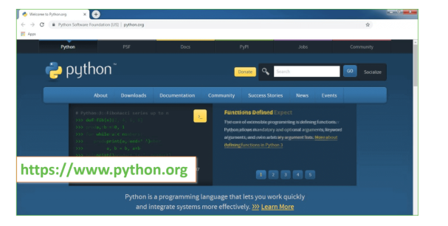

Now, check for the latest and the correct version for your operating system.

Step 2: Click on the Download Tab.

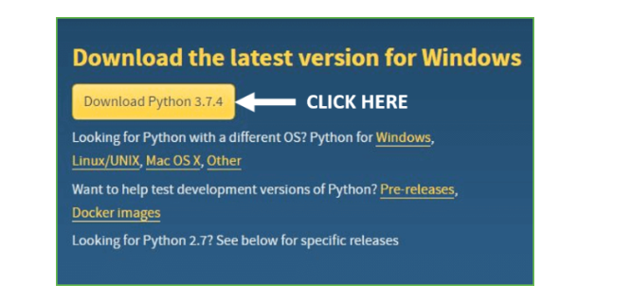

Step 3: You can either select the Download Python for windows 3.7.4 button in Yellow Color or you can scroll further down and click on download with respective to their version. Here, we are downloading the most recent python version for windows 3.7.4

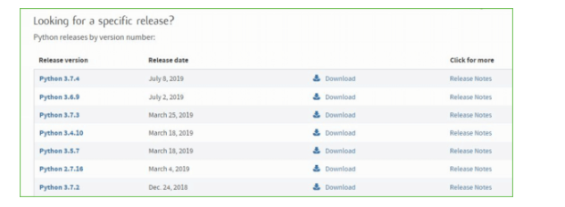

Step 4: Scroll down the page until you find the Files option.

Step 5: Here you see a different version of python along with the operating system.

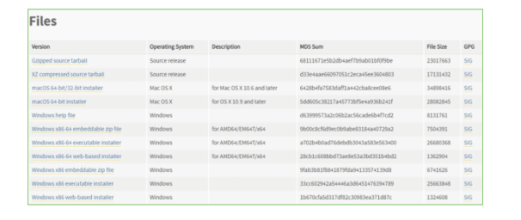

* To download Windows 32-bit python, you can select any one from the three options: Windows x86 embeddable zip file, Windows x86 executable installer or Windows x86 web-based installer.
* To download Windows 64-bit python, you can select any one from the three options: Windows x86-64 embeddable zip file, Windows x86-64 executable installer or Windows x86-64 web-based installer.

Here we will install Windows x86-64 web-based installer. Here your first part regarding which version of python is to be downloaded is completed. Now we move ahead with the second part in installing python i.e., Installation

Note: To know the changes or updates that are made in the version you can click on the Release Note Option.

Installation of Python

Step 1: Go to Download and Open the downloaded python version to carry out the installation process.

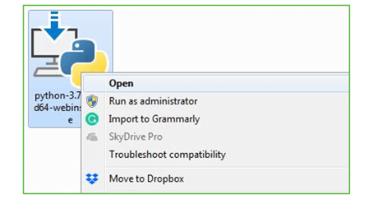

Step 2: Before you click on Install Now, make sure to put a tick on Add Python 3.7 to PATH.

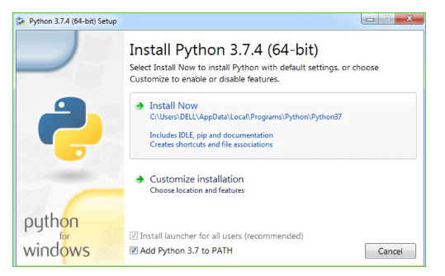

Step 3: Click on Install NOW After the installation is successful. Click on Close.

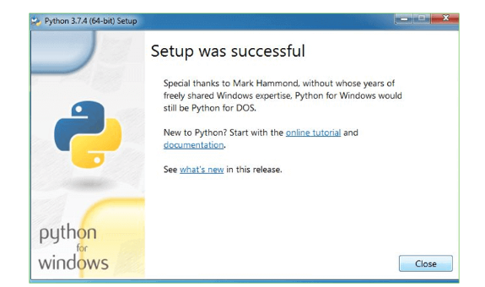

With these above three steps on python installation, you have successfully and correctly installed Python. Now is the time to verify the installation.

Note: The installation process might take a couple of minutes.

Verify the Python Installation

Step 1: Click on Start

Step 2: In the Windows Run Command, type “cmd”.

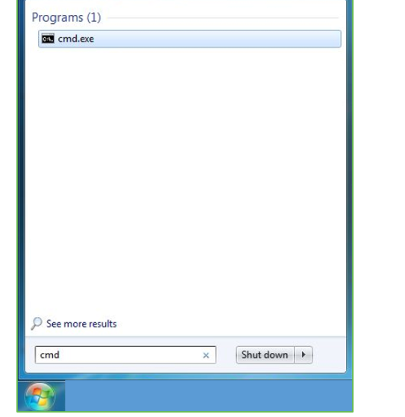

Step 3: Open the Command prompt option.

Step 4: Let us test whether the python is correctly installed. Type python –V and press Enter.

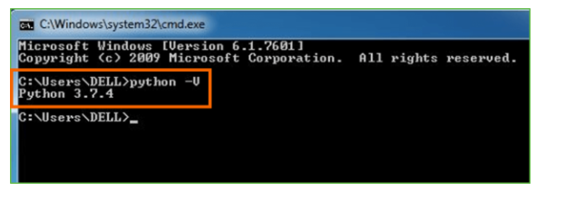

Step 5: You will get the answer as 3.7.4

Note: If you have any of the earlier versions of Python already installed. You must first uninstall the earlier version and then install the new one.

Check how the Python IDLE works

Step 1: Click on Start

Step 2: In the Windows Run command, type “python idle”.

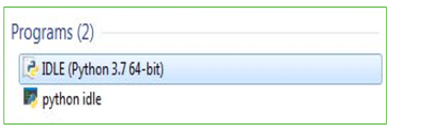

Step 3: Click on IDLE (Python 3.7 64-bit) and launch the program

Step 4: To go ahead with working in IDLE you must first save the file. Click on File > Click on Save

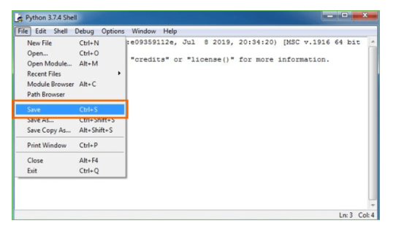

Step 5: Name the file and save as type should be Python files. Click on SAVE. Here I have named the files as Hey World.

Step 6: Now for e.g., enter print (“Hey World”) and Press Enter.

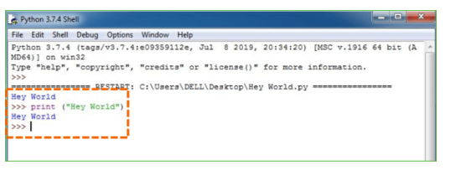

You will see that the command given is launched. With this, we end our tutorial on how to install Python. You have learned how to download python for windows into your respective operating system.

Note: Unlike Java, Python does not need semicolons at the end of the statements otherwise it won’t work.

**What is Machine Learning : -**

Before we take a look at the details of various machine learning methods, let's start by looking at what machine learning is, and what it isn't. Machine learning is often categorized as a subfield of artificial intelligence, but I find that categorization can often be misleading at first brush. The study of machine learning certainly arose from research in this context, but in the data science application of machine learning methods, it's more helpful to think of machine learning as a means of *building models of data*.

Fundamentally, machine learning involves building mathematical models to help understand data. "Learning" enters the fray when we give these models *tunable parameters* that can be adapted to observed data; in this way the program can be considered to be "learning" from the data. Once these models have been fit to previously seen data, they can be used to predict and understand aspects of newly observed data. I'll leave to the reader the more philosophical digression regarding the extent to which this type of mathematical, model-based "learning" is similar to the "learning" exhibited by the human brain. Understanding the problem setting in machine learning is essential to using these tools effectively, and so we will start with some broad categorizations of the types of approaches we'll discuss here.

**Categories Of Machine Leaning :-**

At the most fundamental level, machine learning can be categorized into two main types: supervised learning and unsupervised learning.

*Supervised learning* involves somehow modeling the relationship between measured features of data and some label associated with the data; once this model is determined, it can be used to apply labels to new, unknown data. This is further subdivided into *classification* tasks and *regression* tasks: in classification, the labels are discrete categories, while in regression, the labels are continuous quantities. We will see examples of both types of supervised learning in the following section.

*Unsupervised learning* involves modeling the features of a dataset without reference to any label, and is often described as "letting the dataset speak for itself." These models include tasks such as *clustering* and *dimensionality reduction.* Clustering algorithms identify distinct groups of data, while dimensionality reduction algorithms search for more succinct representations of the data. We will see examples of both types of unsupervised learning in the following section.

**Need for Machine Learning**

Human beings, at this moment, are the most intelligent and advanced species on earth because they can think, evaluate and solve complex problems. On the other side, AI is still in its initial stage and haven’t surpassed human intelligence in many aspects. Then the question is that what is the need to make machine learn? The most suitable reason for doing this is, “to make decisions, based on data, with efficiency and scale”.

Lately, organizations are investing heavily in newer technologies like Artificial Intelligence, Machine Learning and Deep Learning to get the key information from data to perform several real-world tasks and solve problems. We can call it data-driven decisions taken by machines, particularly to automate the process. These data-driven decisions can be used, instead of using programing logic, in the problems that cannot be programmed inherently. The fact is that we can’t do without human intelligence, but other aspect is that we all need to solve real-world problems with efficiency at a huge scale. That is why the need for machine learning arises.

**Challenges in Machines Learning :-**

While Machine Learning is rapidly evolving, making significant strides with cybersecurity and autonomous cars, this segment of AI as whole still has a long way to go. The reason behind is that ML has not been able to overcome number of challenges. The challenges that ML is facing currently are −

Quality of data − Having good-quality data for ML algorithms is one of the biggest challenges. Use of low-quality data leads to the problems related to data preprocessing and feature extraction.

Time-Consuming task − Another challenge faced by ML models is the consumption of time especially for data acquisition, feature extraction and retrieval.

Lack of specialist persons − As ML technology is still in its infancy stage, availability of expert resources is a tough job.

No clear objective for formulating business problems − Having no clear objective and well-defined goal for business problems is another key challenge for ML because this technology is not that mature yet.

Issue of overfitting & underfitting − If the model is overfitting or underfitting, it cannot be represented well for the problem.

Curse of dimensionality − Another challenge ML model faces is too many features of data points. This can be a real hindrance.

Difficulty in deployment − Complexity of the ML model makes it quite difficult to be deployed in real life.

**Applications of Machines Learning :-**

Machine Learning is the most rapidly growing technology and according to researchers we are in the golden year of AI and ML. It is used to solve many real-world complex problems which cannot be solved with traditional approach. Following are some real-world applications of ML −

* Emotion analysis
* Sentiment analysis
* Error detection and prevention
* Weather forecasting and prediction
* Stock market analysis and forecasting
* Speech synthesis
* Speech recognition
* Customer segmentation
* Object recognition
* Fraud detection
* Fraud prevention
* Recommendation of products to customer in online shopping

**How to Start Learning Machine Learning?**

Arthur Samuel coined the term “Machine Learning” in 1959 and defined it as a “Field of study that gives computers the capability to learn without being explicitly programmed”.

And that was the beginning of Machine Learning! In modern times, Machine Learning is one of the most popular (if not the most!) career choices. According to [Indeed](http://blog.indeed.com/2019/03/14/best-jobs-2019/), Machine Learning Engineer Is The Best Job of 2019 with a *344%* growth and an average base salary of $146,085 per year.

But there is still a lot of doubt about what exactly is Machine Learning and how to start learning it? So this article deals with the Basics of Machine Learning and also the path you can follow to eventually become a full-fledged Machine Learning Engineer. Now let’s get started!!!

**How to start learning ML?**

This is a rough roadmap you can follow on your way to becoming an insanely talented Machine Learning Engineer. Of course, you can always modify the steps according to your needs to reach your desired end-goal!

**Step 1 – Understand the Prerequisites**

In case you are a genius, you could start ML directly but normally, there are some prerequisites that you need to know which include Linear Algebra, Multivariate Calculus, Statistics, and Python. And if you don’t know these, never fear! You don’t need a Ph.D. degree in these topics to get started but you do need a basic understanding.

**(a) Learn Linear Algebra and Multivariate Calculus**

Both Linear Algebra and Multivariate Calculus are important in Machine Learning. However, the extent to which you need them depends on your role as a data scientist. If you are more focused on application heavy machine learning, then you will not be that heavily focused on maths as there are many common libraries available. But if you want to focus on R&D in Machine Learning, then mastery of Linear Algebra and Multivariate Calculus is veryimportant as you will have to implement many ML algorithms from scratch.

**(b) Learn Statistics**

Data plays a huge role in Machine Learning. In fact, around 80% of your time as an ML expert will be spent collecting and cleaning data. And statistics is a field that handles the collection, analysis, and presentation of data. So it is no surprise that you need to learn it!!!  
Some of the key concepts in statistics that are important are Statistical Significance, Probability Distributions, Hypothesis Testing, Regression, etc. Also, Bayesian Thinking is also a very important part of ML which deals with various concepts like Conditional Probability, Priors, and Posteriors, Maximum Likelihood, etc.

**(c) Learn Python**

Some people prefer to skip Linear Algebra, Multivariate Calculus and Statistics and learn them as they go along with trial and error. But the one thing that you absolutely cannot skip is [Python](https://www.geeksforgeeks.org/python-programming-language/)! While there are other languages you can use for Machine Learning like R, Scala, etc. Python is currently the most popular language for ML. In fact, there are many Python libraries that are specifically useful for Artificial Intelligence and Machine Learning such as [Keras](https://keras.io/" \t "_blank), [TensorFlow](https://www.tensorflow.org/), [Scikit-learn](https://scikit-learn.org/stable/), etc.

So if you want to learn ML, it’s best if you learn Python! You can do that using various online resources and courses such as [Fork Python](https://practice.geeksforgeeks.org/courses/fork-python) available Free on GeeksforGeeks.

**Step 2 – Learn Various ML Concepts**

Now that you are done with the prerequisites, you can move on to actually learning ML (Which is the fun part!!!) It’s best to start with the basics and then move on to the more complicated stuff. Some of the basic concepts in ML are:

**(a) Terminologies of Machine Learning**

* Model – A model is a specific representation learned from data by applying some machine learning algorithm. A model is also called a hypothesis.
* Feature – A feature is an individual measurable property of the data. A set of numeric features can be conveniently described by a feature vector. Feature vectors are fed as input to the model. For example, in order to predict a fruit, there may be features like color, smell, taste, etc.
* Target (Label) – A target variable or label is the value to be predicted by our model. For the fruit example discussed in the feature section, the label with each set of input would be the name of the fruit like apple, orange, banana, etc.
* Training – The idea is to give a set of inputs(features) and it’s expected outputs(labels), so after training, we will have a model (hypothesis) that will then map new data to one of the categories trained on.
* Prediction – Once our model is ready, it can be fed a set of inputs to which it will provide a predicted output(label).

**(b) Types of Machine Learning**

* Supervised Learning – This involves learning from a training dataset with labeled data using classification and regression models. This learning process continues until the required level of performance is achieved.
* Unsupervised Learning – This involves using unlabelled data and then finding the underlying structure in the data in order to learn more and more about the data itself using factor and cluster analysis models.
* Semi-supervised Learning – This involves using unlabelled data like Unsupervised Learning with a small amount of labeled data. Using labeled data vastly increases the learning accuracy and is also more cost-effective than Supervised Learning.
* Reinforcement Learning – This involves learning optimal actions through trial and error. So the next action is decided by learning behaviors that are based on the current state and that will maximize the reward in the future.

**Advantages of Machine learning :-**

**1. Easily identifies trends and patterns -**

Machine Learning can review large volumes of data and discover specific trends and patterns that would not be apparent to humans. For instance, for an e-commerce website like Amazon, it serves to understand the browsing behaviors and purchase histories of its users to help cater to the right products, deals, and reminders relevant to them. It uses the results to reveal relevant advertisements to them.

**2. No human intervention needed (automation)**

With ML, you don’t need to babysit your project every step of the way. Since it means giving machines the ability to learn, it lets them make predictions and also improve the algorithms on their own. A common example of this is anti-virus softwares; they learn to filter new threats as they are recognized. ML is also good at recognizing spam.

**3. Continuous Improvement**

As [ML algorithms](https://data-flair.training/blogs/machine-learning-algorithms/) gain experience, they keep improving in accuracy and efficiency. This lets them make better decisions. Say you need to make a weather forecast model. As the amount of data you have keeps growing, your algorithms learn to make more accurate predictions faster.

**4. Handling multi-dimensional and multi-variety data**

Machine Learning algorithms are good at handling data that are multi-dimensional and multi-variety, and they can do this in dynamic or uncertain environments.

**5. Wide Applications**

You could be an e-tailer or a healthcare provider and make ML work for you. Where it does apply, it holds the capability to help deliver a much more personal experience to customers while also targeting the right customers.

**Disadvantages of Machine Learning :-**

**1. Data Acquisition**

Machine Learning requires massive data sets to train on, and these should be inclusive/unbiased, and of good quality. There can also be times where they must wait for new data to be generated**.**

**2. Time and Resources**

ML needs enough time to let the algorithms learn and develop enough to fulfill their purpose with a considerable amount of accuracy and relevancy. It also needs massive resources to function. This can mean additional requirements of computer power for you.

**3. Interpretation of Results**

Another major challenge is the ability to accurately interpret results generated by the algorithms. You must also carefully choose the algorithms for your purpose.

**4. High error-susceptibility**

[Machine Learning](https://en.wikipedia.org/wiki/Machine_learning) is autonomous but highly susceptible to errors. Suppose you train an algorithm with data sets small enough to not be inclusive. You end up with biased predictions coming from a biased training set. This leads to irrelevant advertisements being displayed to customers. In the case of ML, such blunders can set off a chain of errors that can go undetected for long periods of time. And when they do get noticed, it takes quite some time to recognize the source of the issue, and even longer to correct it.

# **SYSTEM TEST**

The purpose of testing is to discover errors. Testing is the process of trying to discover every conceivable fault or weakness in a work product. It provides a way to check the functionality of components, sub assemblies, assemblies and/or a finished product It is the process of exercising software with the intent of ensuring that the Software system meets its requirements and user expectations and does not fail in an unacceptable manner. There are various types of test. Each test type addresses a specific testing requirement.

**TYPES OF TESTS**

**Unit testing**

Unit testing involves the design of test cases that validate that the internal program logic is functioning properly, and that program inputs produce valid outputs. All decision branches and internal code flow should be validated. It is the testing of individual software units of the application .it is done after the completion of an individual unit before integration. This is a structural testing, that relies on knowledge of its construction and is invasive. Unit tests perform basic tests at component level and test a specific business process, application, and/or system configuration. Unit tests ensure that each unique path of a business process performs accurately to the documented specifications and contains clearly defined inputs and expected results.

**Integration testing**

Integration tests are designed to test integrated software components to determine if they actually run as one program. Testing is event driven and is more concerned with the basic outcome of screens or fields. Integration tests demonstrate that although the components were individually satisfaction, as shown by successfully unit testing, the combination of components is correct and consistent. Integration testing is specifically aimed at exposing the problems that arise from the combination of components.

**Functional test**

Functional tests provide systematic demonstrations that functions tested are available as specified by the business and technical requirements, system documentation, and user manuals.

Functional testing is centered on the following items:

Valid Input : identified classes of valid input must be accepted.

Invalid Input : identified classes of invalid input must be rejected.

Functions : identified functions must be exercised.

Output : identified classes of application outputs must be exercised.

Systems/Procedures : interfacing systems or procedures must be invoked.

Organization and preparation of functional tests is focused on requirements, key functions, or special test cases. In addition, systematic coverage pertaining to identify Business process flows; data fields, predefined processes, and successive processes must be considered for testing. Before functional testing is complete, additional tests are identified and the effective value of current tests is determined.

**System Test**

System testing ensures that the entire integrated software system meets requirements. It tests a configuration to ensure known and predictable results. An example of system testing is the configuration oriented system integration test. System testing is based on process descriptions and flows, emphasizing pre-driven process links and integration points.

**White Box Testing**

White Box Testing is a testing in which in which the software tester has knowledge of the inner workings, structure and language of the software, or at least its purpose. It is purpose. It is used to test areas that cannot be reached from a black box level.

**Black Box Testing**

Black Box Testing is testing the software without any knowledge of the inner workings, structure or language of the module being tested. Black box tests, as most other kinds of tests, must be written from a definitive source document, such as specification or requirements document, such as specification or requirements document. It is a testing in which the software under test is treated, as a black box .you cannot “see” into it. The test provides inputs and responds to outputs without considering how the software works.

**Unit Testing**

Unit testing is usually conducted as part of a combined code and unit test phase of the software lifecycle, although it is not uncommon for coding and unit testing to be conducted as two distinct phases.

Test strategy and approach

Field testing will be performed manually and functional tests will be written in detail.

Test objectives

* All field entries must work properly.
* Pages must be activated from the identified link.
* The entry screen, messages and responses must not be delayed.

**Features to be tested**

* Verify that the entries are of the correct format
* No duplicate entries should be allowed
* All links should take the user to the correct page.

**Integration Testing**

Software integration testing is the incremental integration testing of two or more integrated software components on a single platform to produce failures caused by interface defects.

The task of the integration test is to check that components or software applications, e.g. components in a software system or – one step up – software applications at the company level – interact without error.

**Test Results:** All the test cases mentioned above passed successfully. No defects encountered.

**Acceptance Testing**

User Acceptance Testing is a critical phase of any project and requires significant participation by the end user. It also ensures that the system meets the functional requirements.

**Test Results:** All the test cases mentioned above passed successfully. No defects encountered.

**RESULTS:**

**Dataset Description:**

This dataset captures various attributes of students enrolled in a particular course presentation. It integrates demographic data, academic history, and behavioral indicators to assist in predictive analytics—particularly for identifying students at risk.

**✅ Primary Columns:**

| **Column Name** | **Description** |
| --- | --- |
| **code\_module** | Identifier for the academic module (e.g., "AAA"). |
| **code\_presentation** | Identifier for the semester and year of course delivery (e.g., "2013J" for 2013 January). |
| **id\_student** | Unique identifier for each student. |
| **imd\_band** | Index of Multiple Deprivation band (e.g., "90-100%" indicates least deprived, "0-10%" most deprived). |
| **num\_of\_prev\_attempts** | Number of times the student has previously attempted this module. |
| **studied\_credits** | Number of credits the student is studying during the presentation. |
| **final\_result** | Binary outcome label indicating success (1) or failure (0). |
| **total\_clicks** | Total number of clicks (i.e., interactions) recorded by the student on the virtual learning environment. |
| **date\_registration** | Number of days before the module start date that the student registered (negative = before start). |
| **date\_unregistration** | Number of days from start the student unregistered (0 if did not unregister). |

**👤 Demographic Encoding (One-Hot):**

| **Category** | **Feature Prefix** | **Example Features** |
| --- | --- | --- |
| **Gender** | gender\_ | gender\_M = TRUE for male |
| **Region** | region\_ | region\_London Region, region\_Scotland, etc. |
| **Highest Education** | highest\_education\_ | highest\_education\_HE Qualification, etc. |
| **Age Band** | age\_band\_ | age\_band\_35-55, age\_band\_55<= |
| **Disability** | disability\_ | disability\_Y = TRUE if student reported a disability |

**🧠 Usage**

This dataset is primarily used in **student risk prediction models** to evaluate:

* Engagement behavior via total\_clicks
* Academic history and progression
* Socioeconomic impact using imd\_band
* Reg ional and demographic trends

**Output Screens:**

**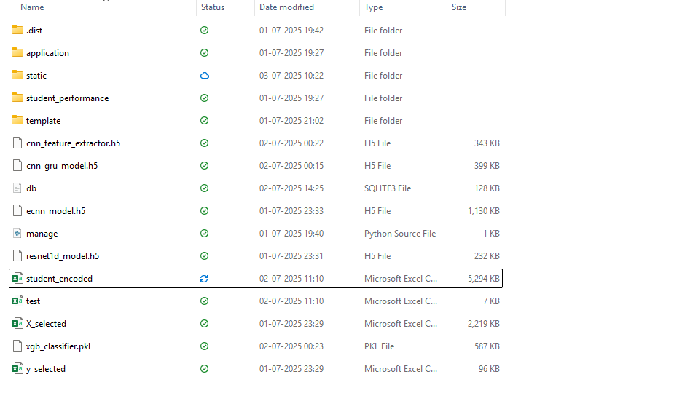**

The above is the project folder, from here we have to access the command prompt. 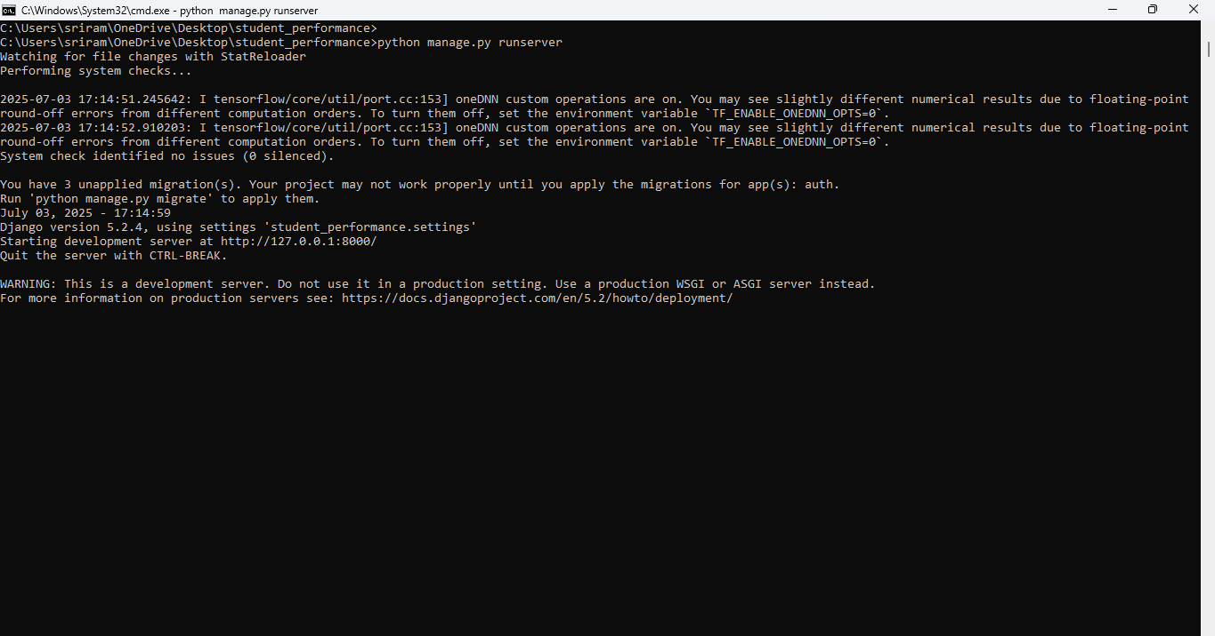

Follow the above function: python manage.py runserver and then we will get the following:  
<http://127.0.0.1:8000/>

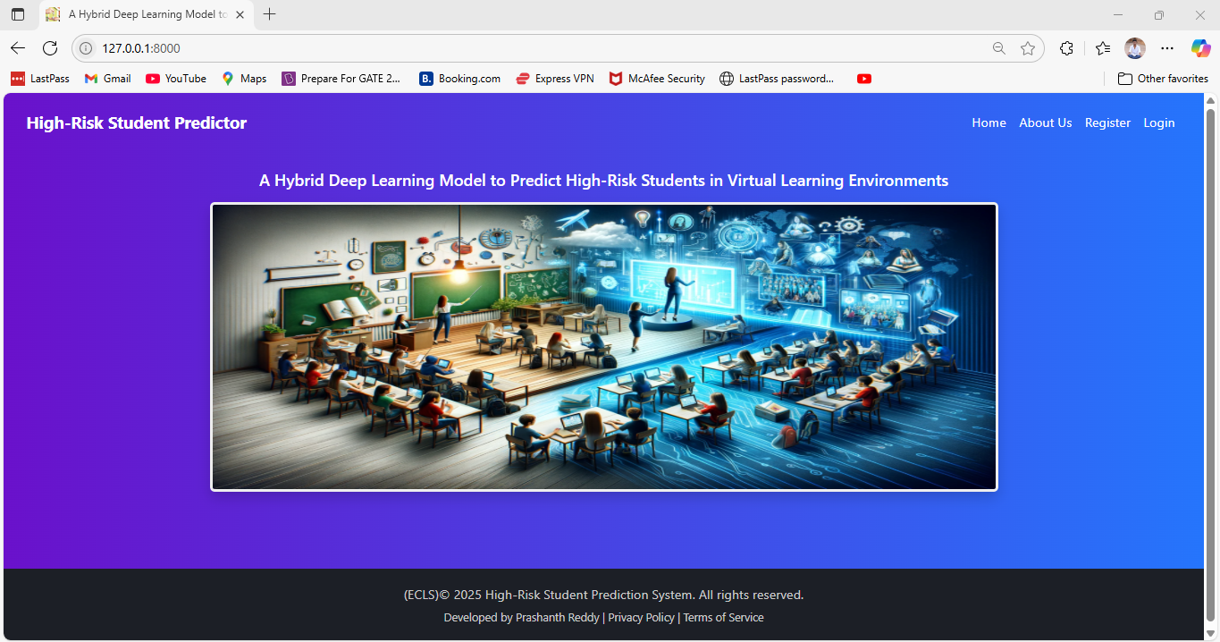

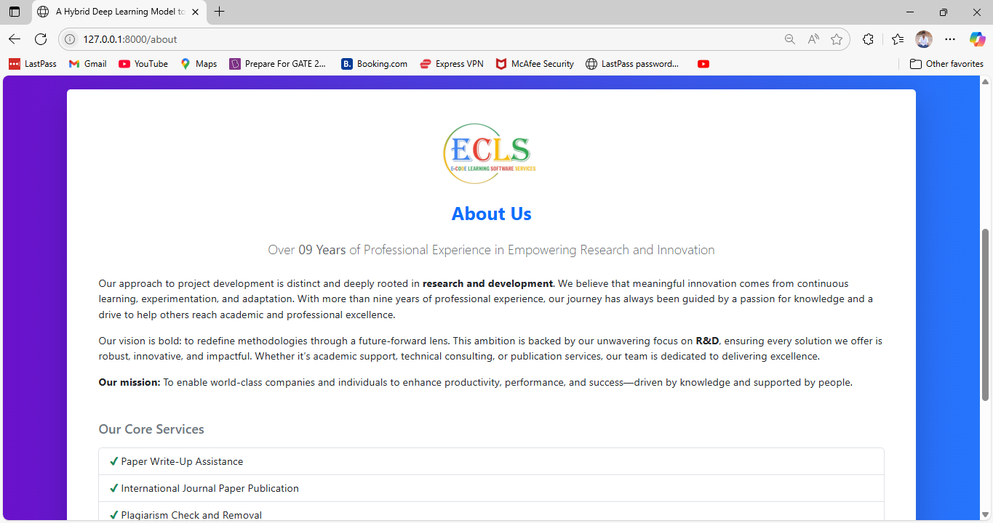

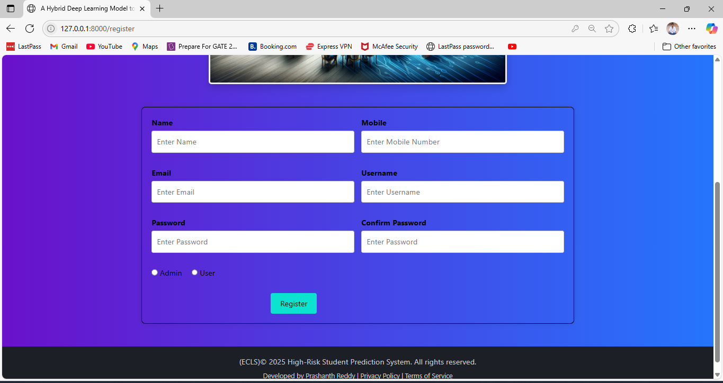 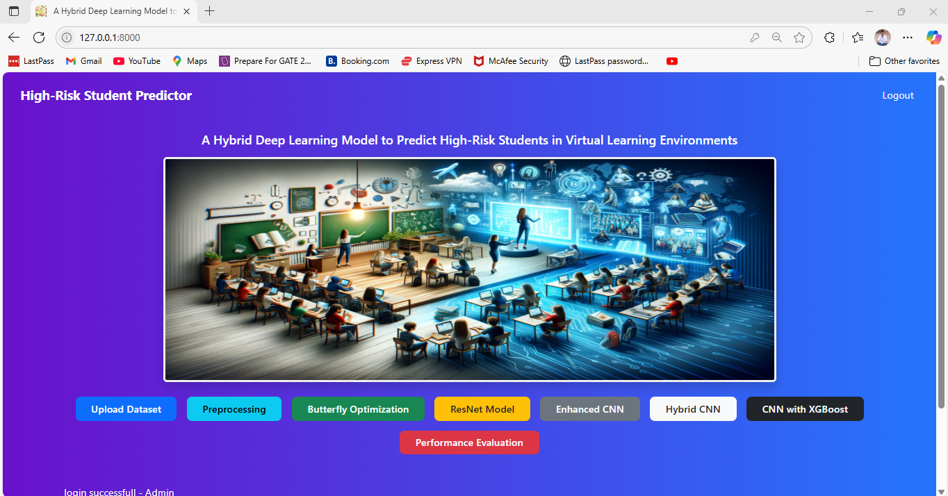

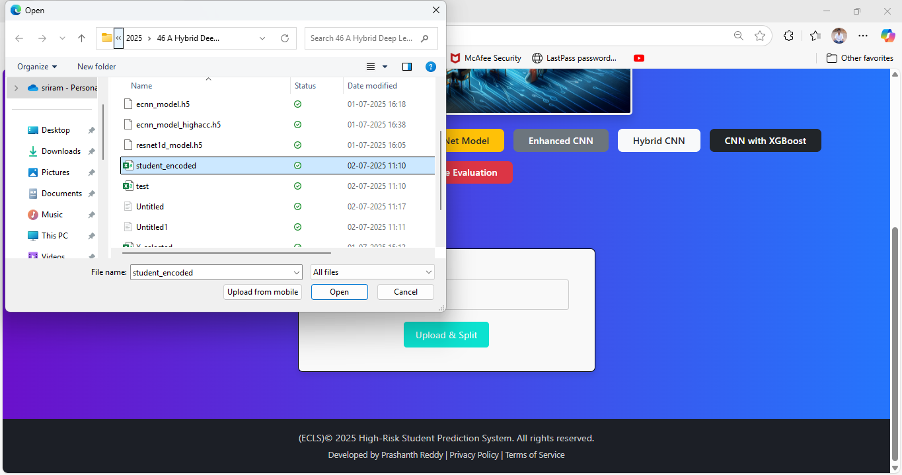

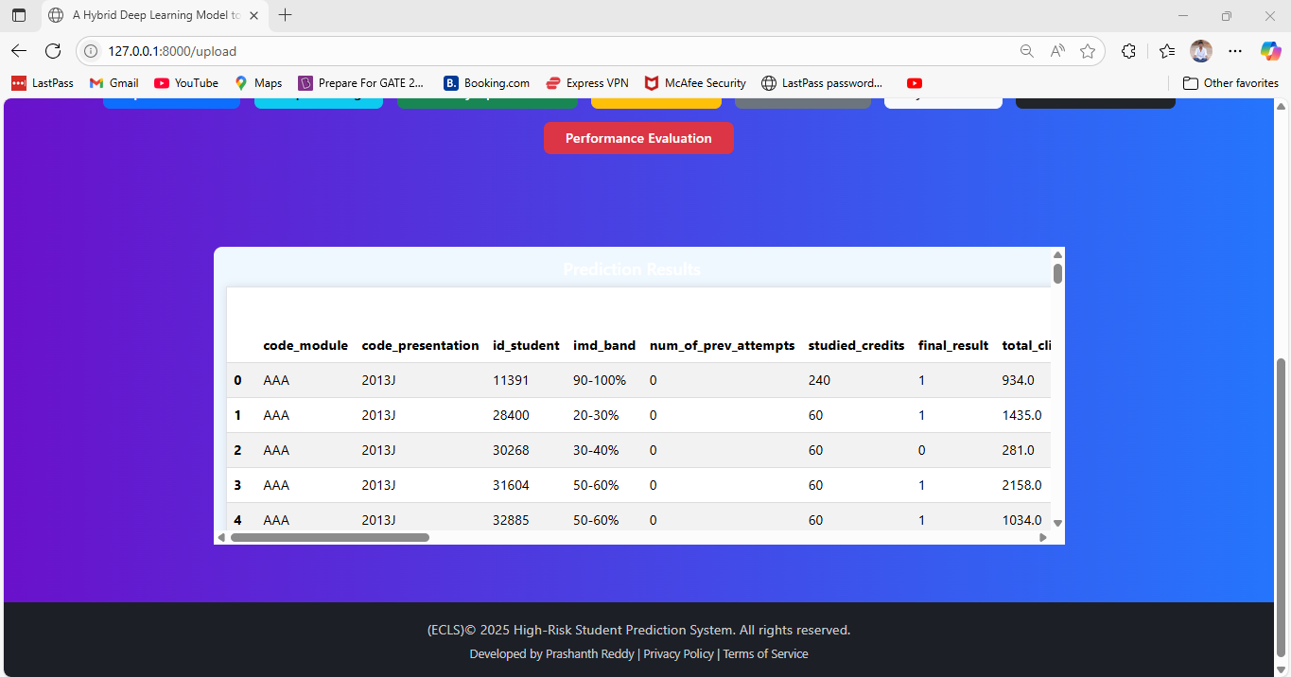

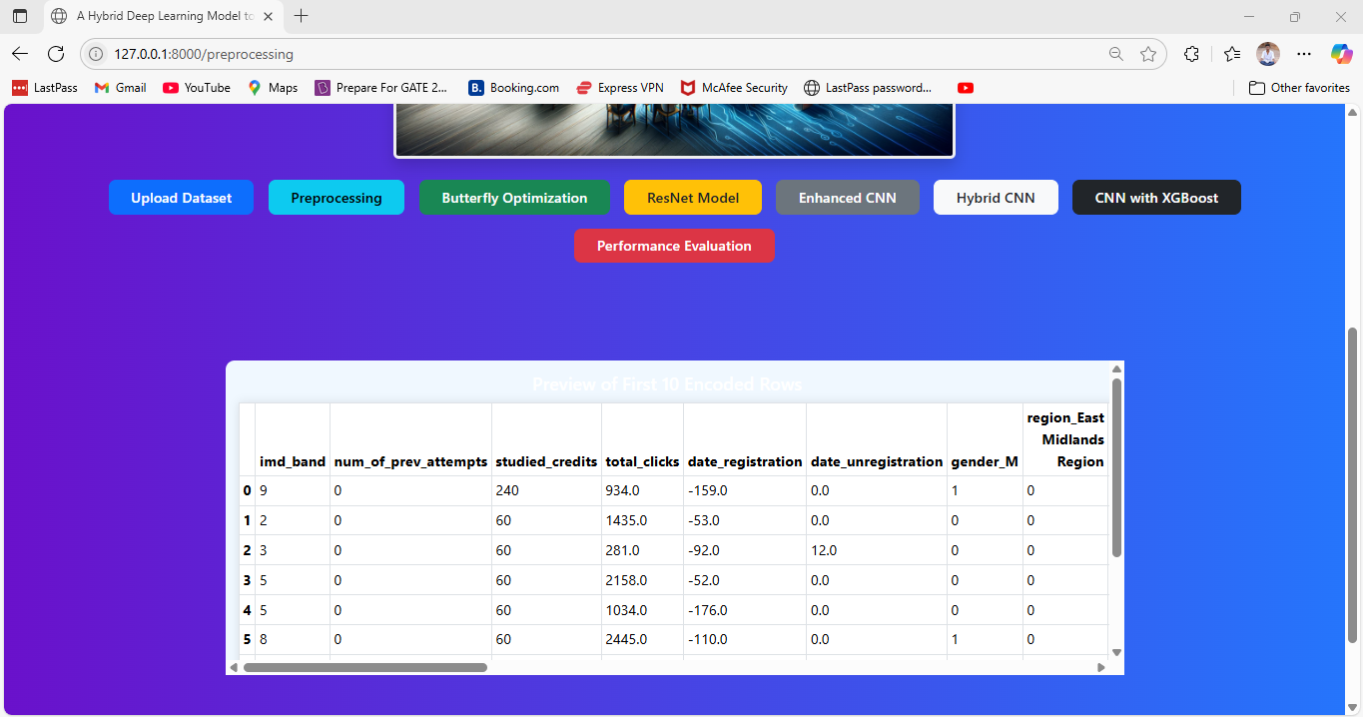

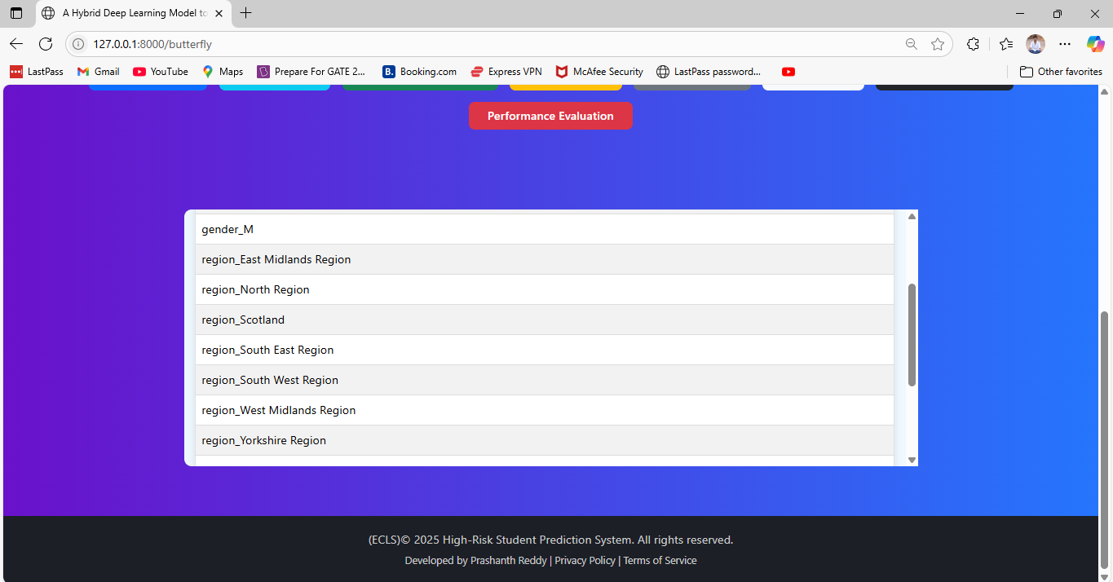

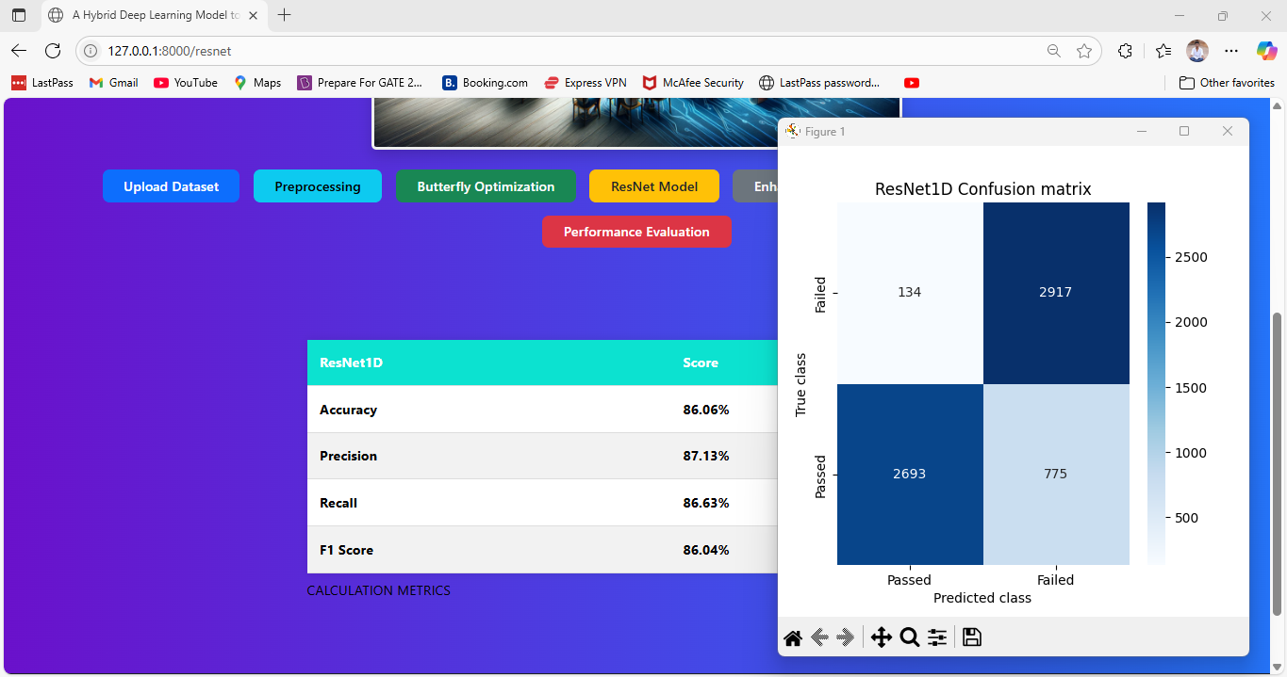

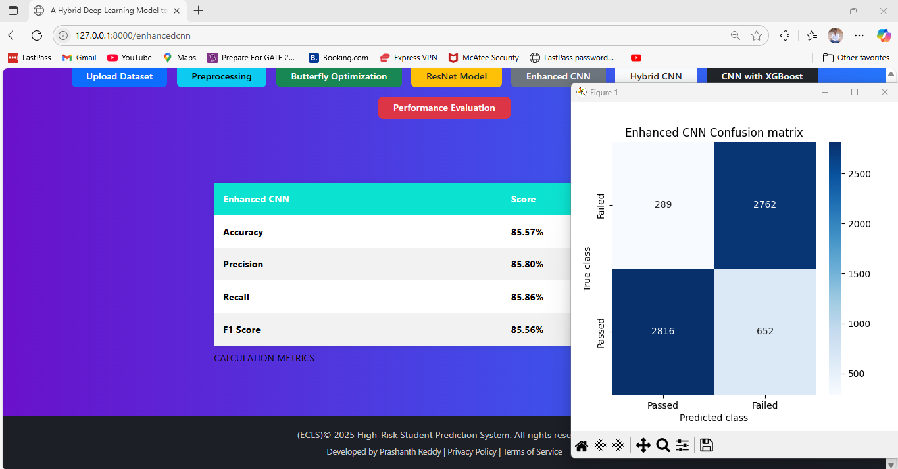 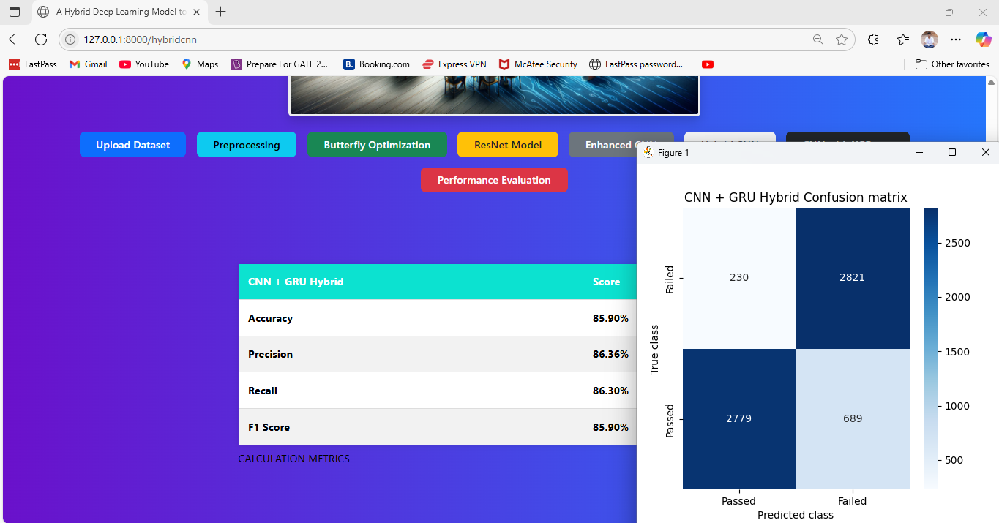

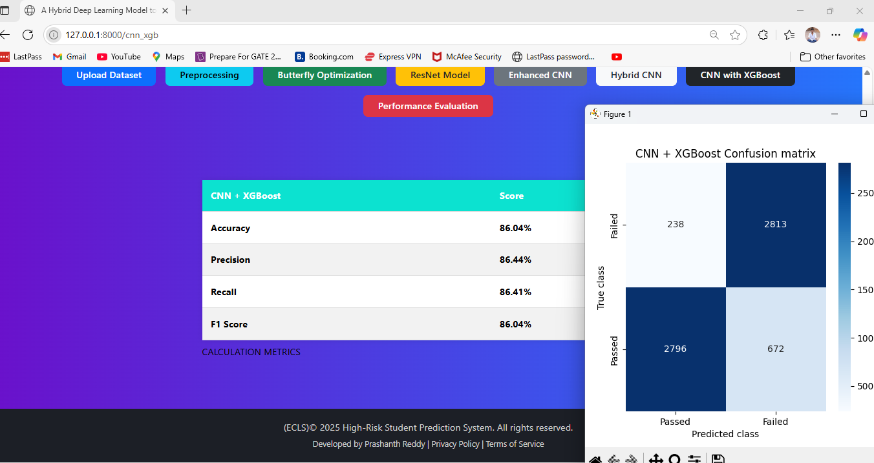

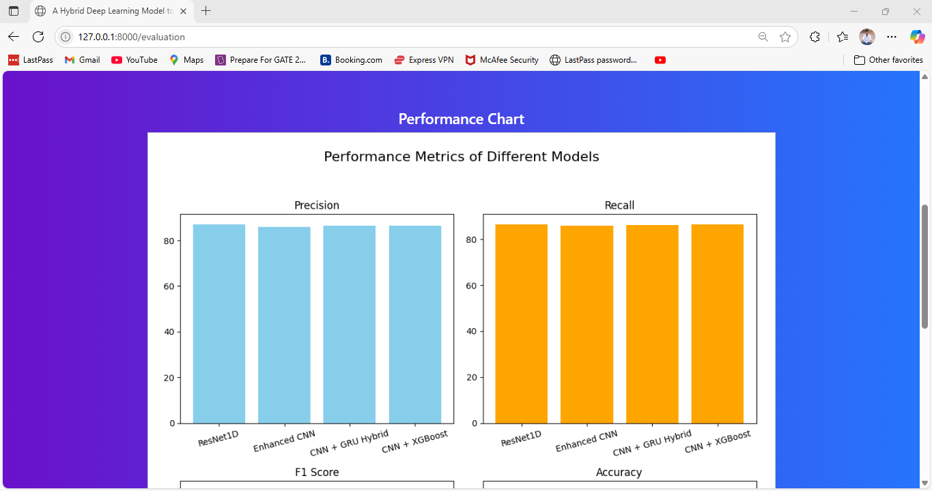

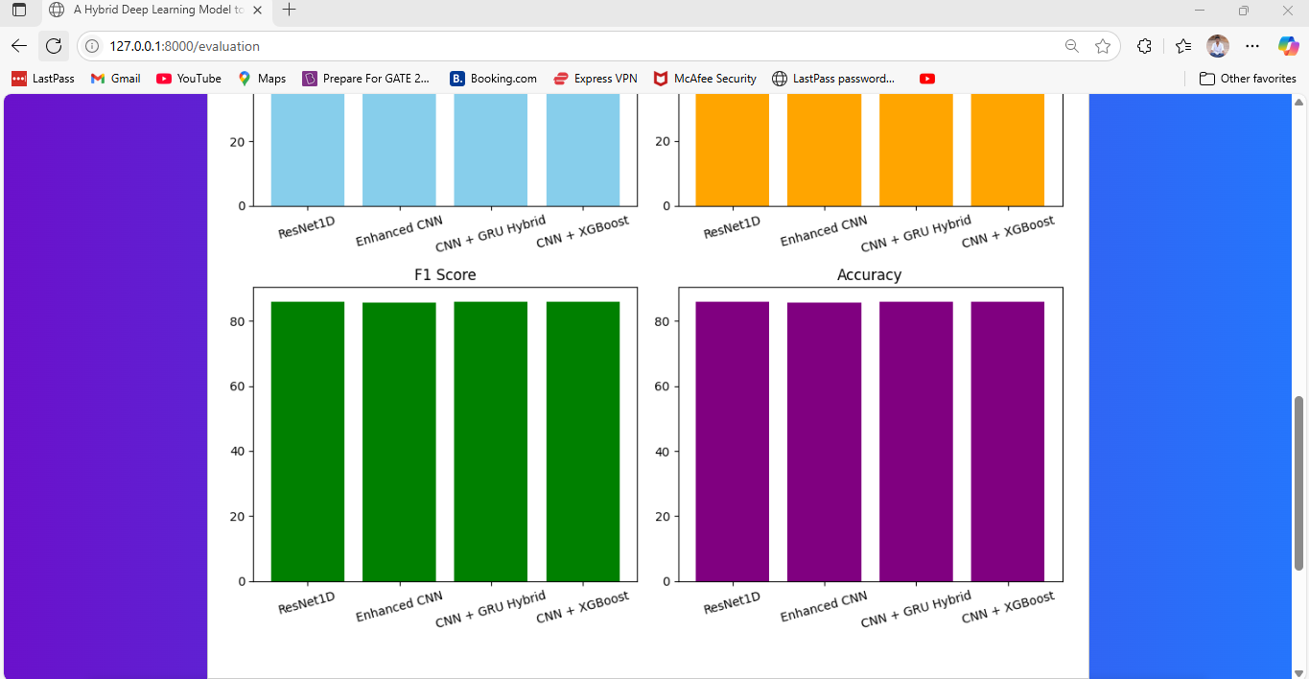 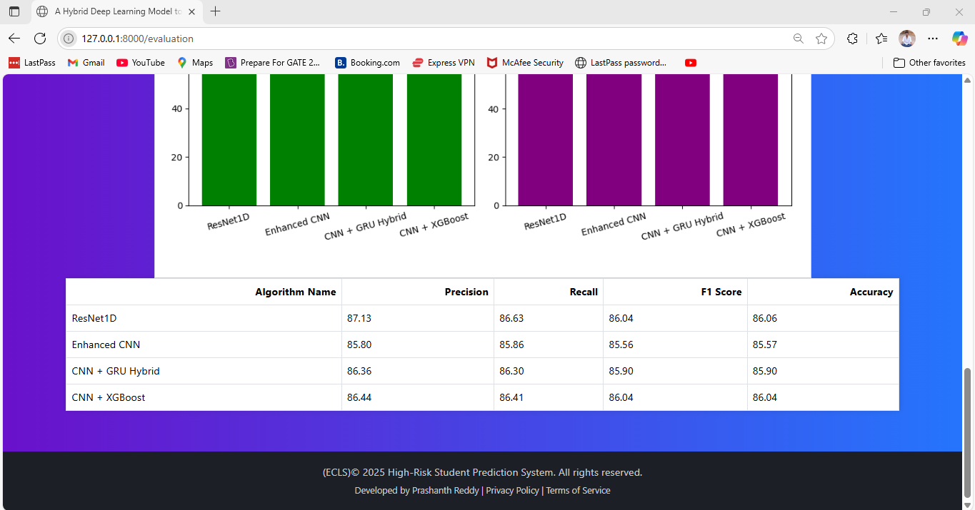 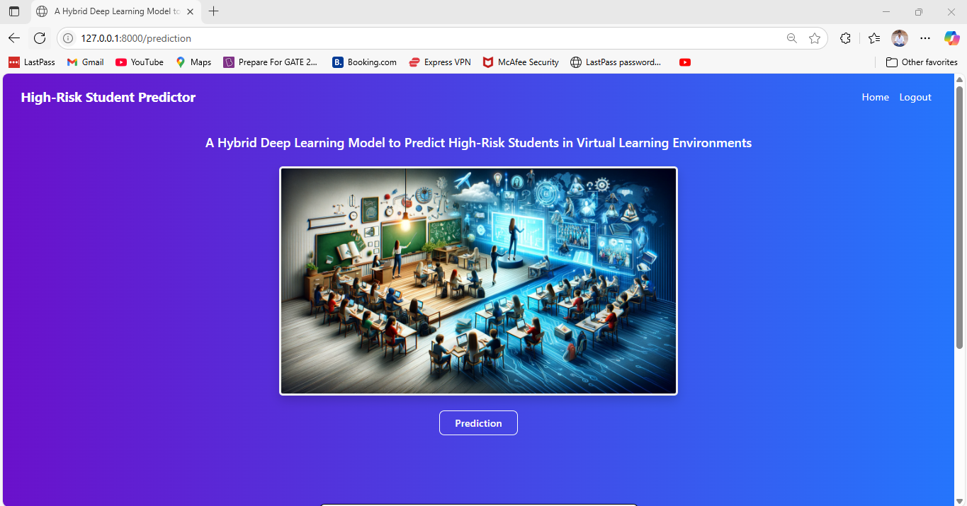 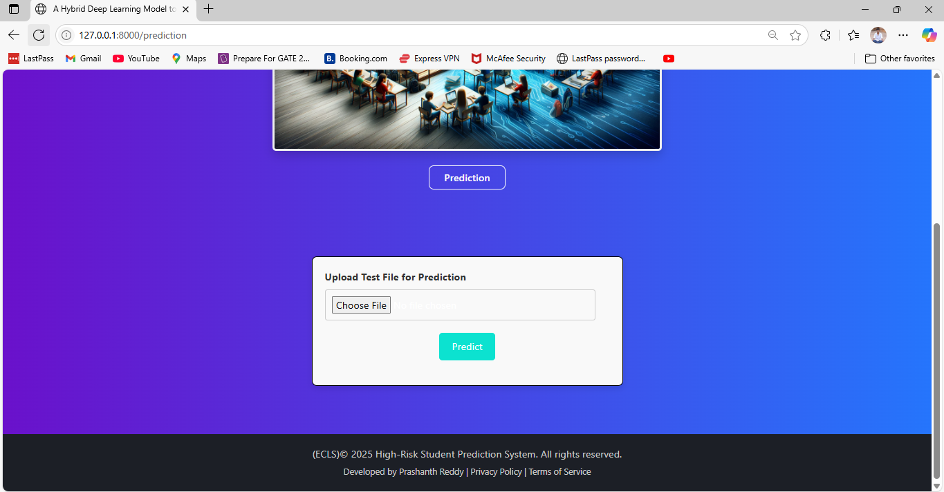 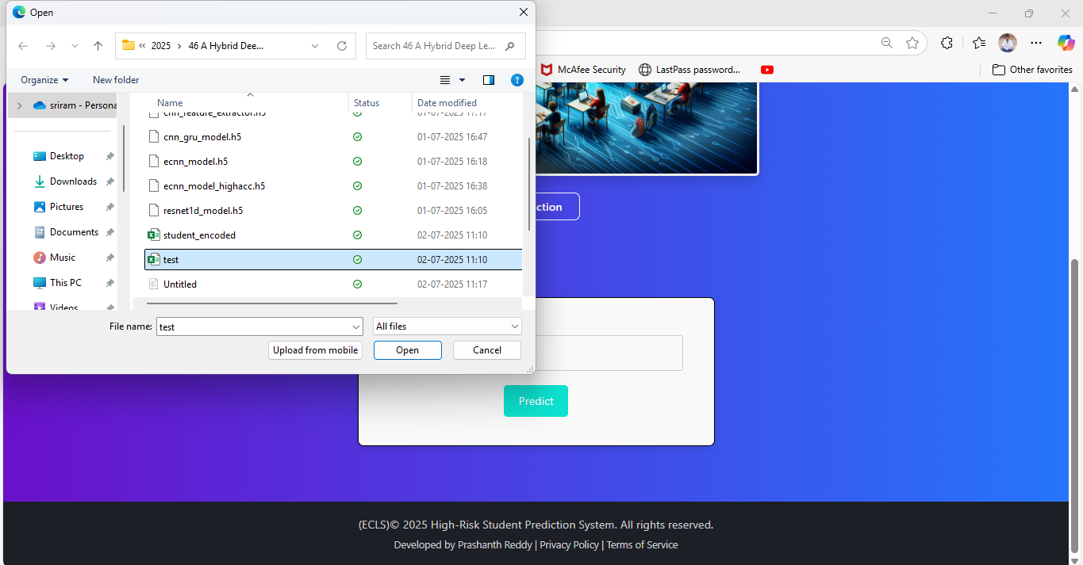

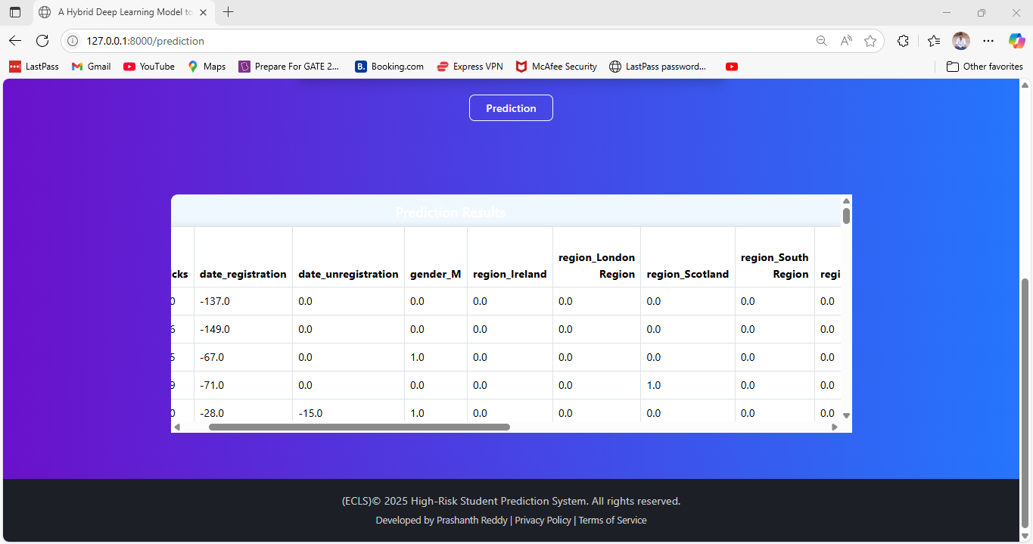

**Conclusion**

This study successfully demonstrated the development of a robust system to predict high-risk students in virtual learning environments using a hybrid deep learning framework. Through the integration of multiple advanced models—ResNet1D, Enhanced CNN, Hybrid CNN-GRU, and CNN with XGBoost—alongside Butterfly Optimization for feature selection, the system exhibited significant improvement in prediction accuracy and model efficiency. The proposed architecture ensures early identification of academically vulnerable students, empowering educators to provide timely interventions. By combining behavioral data, academic history, and demographic features, the system offers a holistic view of student risk profiles. The modular design enhances flexibility and scalability, making it applicable to various educational institutions. Overall, this model fosters data-driven decision-making in e-learning systems, thereby promoting better educational outcomes and reducing dropout rates.

**Future Scope**

While the current model achieves high accuracy in identifying at-risk students, there remain several avenues for future exploration. The integration of real-time data streams from learning management systems (LMS) can further enhance predictive capabilities. Moreover, the inclusion of natural language processing (NLP) techniques to analyze discussion forums, assignment texts, and feedback could add contextual depth to student profiling. Extending the system to incorporate time-series forecasting could enable dynamic monitoring of student performance over the semester. Future work could also explore federated learning to protect student privacy while utilizing distributed data sources across institutions. Additionally, adapting the model for use in mobile or lightweight platforms could improve accessibility for educators. Collaborations with educational psychologists may also refine risk indicators and improve intervention strategies. As education becomes increasingly digital, this predictive system can evolve into a comprehensive decision-support tool for personalized and inclusive learning environments.

REFERENCES

[1] E. Ahn, Y. Gil, and E. Putnam-Hornstein, ‘‘Predicting youth at high risk of aging out of foster care using machine learning meth ods,’’ Child Abuse Neglect, vol. 117, Jul. 2021, Art. no. 105059, doi: 10.1016/j.chiabu.2021.105059.

[2] R. Dembo and W. Walters, ‘‘Innovative approaches to identifying and responding totheneedsofhighriskyouth,’’SubstanceUseMisuse,vol.38, nos. 11–13, pp. 1713–1738, Jan. 2003, doi: 10.1081/ja-120024238.

[3] H. H. Severson, H. M. Walker, J. Hope-Doolittle, T. R. Kratochwill, and F. M. Gresham, ‘‘Proactive, early screening to detect behaviorally at risk students: Issues, approaches, emerging innovations, and professional practices,’’ J. School Psychol., vol. 45, no. 2, pp. 193–223, Apr. 2007, doi: 10.1016/j.jsp.2006.11.003.

[4] M. Yağcı, ‘‘Educational data mining: Prediction of students’ academic performance using machine learning algorithms,’’ Smart Learn. Environ., vol. 9, no. 1, p. 11, Dec. 2022, doi: 10.1186/s40561-022-00192-z.

[5] T. O. Olaleye and O. R. Vincent, ‘‘A predictive model for students’ per formance and risk level indicators using machine learning,’’ in Proc. Int. Conf. Math., Comput. Eng. Comput. Sci. (ICMCECS), Mar. 2020, pp. 1–7, doi: 10.1109/ICMCECS47690.2020.240897.

[6] A. Marwaha and A. Singla, ‘‘A study of factors to predict at-risk students based on machine learning techniques,’’ in Advances in Intelligent Systems and Computing. Singapore: Springer, 2020, pp. 133–141.

[7] O. Embarak, ‘‘Apply machine learning algorithms to predict at-risk stu dents to admission period,’’ in Proc. 7th Int. Conf. Inf. Technol. Trends (ITT), Nov. 2020, pp. 190–195, doi: 10.1109/ITT51279.2020.9320878.

[8] W. Xiao, P. Ji, and J. Hu, ‘‘A survey on educational data mining methods used for predicting students’ performance,’’ Eng. Rep., vol. 4, no. 5, May 2022, doi: 10.1002/eng2.12482.

[9] S.D.A.Bujang,A.Selamat,andO.Krejcar,‘‘Apredictiveanalytics model for students grade prediction by supervised machine learning,’’ IOP Conf. Ser. Mater. Sci. Eng., vol. 1051, no. 1, Feb. 2021, Art. no. 012005, doi: 10.1088/1757-899X/1051/1/012005.

[10] L. Ismail, H. Materwala, and A. Hennebelle, ‘‘Comparative analy sis of machine learning models for students’ performance prediction,’’ in Advances in Digital Science. Cham, Switzerland: Springer, 2021, pp. 149–160.

[11] S. Gaftandzhieva, A. Talukder, N. Gohain, S. Hussain, P. Theodorou, Y. K. Salal, and R. Doneva, ‘‘Exploring online activities to predict the final grade of student,’’ Mathematics, vol. 10, no. 20, p. 3758, Oct. 2022, doi: 10.3390/math10203758.

[12] R. Ayienda, R. Rimiru, and W. Cheruiyot, ‘‘Predicting students academic performance using a hybrid of machine learning algo rithms,’’ in Proc. IEEE AFRICON, Sep. 2021, pp. 1–6, doi: 10.1109/ AFRICON51333.2021.9571012.

[13] B. S. Kalyani, D. Harisha, V. RamyaKrishna, and S. Manne, ‘‘Evaluation of students performance using neural networks,’’ in Advances in Intelligent Systems andComputing.Cham,Switzerland:Springer,2020,pp. 499–505.

[14] N. Naicker, T. Adeliyi, and J. Wing, ‘‘Linear support vector machines for prediction of student performance in school-based education,’’ Math. Problems Eng., vol. 2020, pp. 1–7, Oct. 2020, doi: 10.1155/2020/4761468.

[15] X. Wang, X. Yu, L. Guo, F. Liu, and L. Xu, ‘‘Student performance predic tion with short-term sequential campus behaviors,’’ Information, vol. 11, no. 4, p. 201, Apr. 2020, doi: 10.3390/info11040201.  
 [16] K. Neha, J. Sidiq, and M. Zaman, ‘‘Deep neural network model for identification of predictive variables and evaluation of student’s aca demic performance,’’ Revue d’Intelligence Artificielle, vol. 35, no. 5, pp. 409–415, Oct. 2021, doi: 10.18280/ria.350507.

[17] S. Begum and S. S. Padmannavar, ‘‘Genetically optimized ensem ble classifiers for multiclass student performance prediction,’’ Int. J. Intell. Eng. Syst., vol. 15, no. 2, pp. 316–328, Apr. 2022, doi: 10.22266/ijies2022.0430.29